National Conference on Law and Higher Education
Stetson University College of Law
February 20-22, 2005

A NOTE RE THE MISCONDUCT OF ACADEMICS IN UK HEIs

David Palfreyman
OxCHEPS and New College, Oxford University

A) UK EMPLOYMENT LAW GENERALLY

1. The concept of ‘progressive discipline’ is fundamental to UK employment protection legislation which is in turn heavily influenced by EU Directives themselves rooted in European civil law. Such legislation has over the last thirty years essentially overridden the English common law contract of employment which otherwise might have remained very similar to the concept of ‘at will’ employment still largely prevailing in the USA.

2. As in the US there are also the complications of anti-discrimination legislation impacting on the contract of employment (on race and sex since the 1970s, on disability only from the mid-1990s, and on religion and sexual orientation even more recently; and with age due from 2006). There is also legislation on minimum rates of pay and on health and safety at work, and also public interest disclosure legislation to protect ‘whistleblowers’, as well as EU laws concerning the free movement of workers and the regulation of maximum weekly working hours. Tort law kicks in with regard to whether an employer negligently causes an employee an unreasonable amount of workplace stress. Finally, there are protections within the Human Rights Act 1998 which impact on the employer-employee legal relationship.

3. The general employment protection legislation, reinforced by the EU-driven 2002 Employment Act, and its ‘family friendly’ measures, now builds in a strong emphasis on procedural fairness in handling grievance and discipline processes; the level of fairness being closer to the simple following of the rules of natural justice (‘contractual due process’ in US terms, rather than the formal demands of ‘constitutional due process’). An Employment Tribunal will automatically find ‘unfair dismissal’ (cf the common law concept of ‘wrongful dismissal’ in breach of the employment contract) where these basic rules of fairness have been broken by an employer and will award compensation (statutory limit of c£60K/c$100K): but compensation is unlimited in respect of sex/race/disability discrimination within the workplace, and these have been high profile – high claims cases concerning alleged discrimination against highly paid female senior staff in the London offices of American (and supposedly very macho) investment banks….

4. That said, the common law has not been unchanging: the courts in recent years have developed the implied term of mutual trust and confidence (employer and employee must each behave responsibly with regard to the interests and concerns of the other): this term now stands alongside such implied terms upon the employee as obedience, care and skill, fidelity, co-operation, flexibility, and loyalty.

5. All of the above is generic to any UK employer: employee legal relationships; it is now time to turn to the specific issue of the HEI employer dealing with the misconduct of academic staff short of seeking their dismissal from employment…

B) THE MISCONDUCT OF ACADEMICS

1. UK academics misbehave as employees in much the same way as US faculty, and their HEIs as employers respond in much the same way as US HEIs: see Chapter 5 (‘Managing Tricky Situations’) of A. Hall, 2003, Managing People (in the Open University Press/McGraw-Hill ‘Managing Universities and Colleges: Guides to good practice’ 15-volume series edited by Warner and Palfreyman).

2. Such misconduct will be dealt with as for any other employee under the three-step formal disciplinary procedure which the Law requires all employers to have in place (statement of offence – disciplinary meeting – an opportunity to appeal): see below as Attachment A an extract from the Personnel Handbook for New College, Oxford, which relates to all employees except academics/faculty.

3. UK HEIs are roughly half ‘old’ chartered corporations (akin to private US HEIs) and half ‘new’/‘post-1992’ statutory corporations (still private corporations as opposed to US State HEIs, but created by legislation in 1992 when the former polytechnics became universities). The latter will have grievance and disciplinary procedures very similar to the one for New College employees which will apply equally to academics/faculty and all other non-academic employees (see as Attachment B the one for Oxford Brookes University).

4. The position is more complicated in the ‘old’/’pre-1991’ chartered HEIs where ‘the Model Statute’ (imposed into their statutes by s206 of the Education Reform Act 1988 which ended the role of the Visitor in relation to HEI: academic staff disputes) specifies disciplinary procedures for academic staff. The Model Statute of the early-1990s was recently revised in draft by the Privy Council so as to be compatible with the requirements of the 2002 Employment Act referred to above.

C) THE MODEL STATUTE

1. The revised Model Statute is set out as Attachment C below, and provides for disciplinary procedures to deal with matters less serious than ones where dismissal would be appropriate, and also sets out the range of penalties short of dismissal – the ‘progressive discipline’ range of written warnings, the withholding of salary increments, suspension without pay for up to three months, and demotion and/or loss of title (and compensation to University/another colleague!). Note, however, that not all chartered HEIs have necessarily (yet) adopted these changes. The Model Statute effectively imports into the academic staff contract of employment considerations very similar to those applying in the statute law of unfair dismissal referred to above: an emphasis on procedural steps being properly taken in reaching a decision and on the employee’s decision to dismiss being reasonable (one that is within ‘the band of reasonable responses’ to the circumstances by a reasonable employer). The provisions of the Model Statute, as amended in 2002, broadly comply with the procedural requirements of the 2002 Employment Act and the latest ACAS code of practice on discipline and grievance procedures.

2. As for academic freedom, the following is extracted from Higher Education Law (Palfreyman & Warner, 2002):

10.14 One of the purposes of ss 202-207 of the ERA [Education Reform Act] 1988 was to remove from the jurisdiction of the Visitor most disputes between lecturers (and others whose employment was subject to that jurisdiction at the time of the passing of that Act) and the HEIs by which they were employed. The results are stated in paras 10.5 et seq. Another purpose of those sections was to regulate certain aspects of the employment of lecturers in HEIs. Section 202 established a body of persons, known as the University Commissioners (the Commissioners). In exercising their functions under ss 203-207 of the ERA 1988, the Commissioners were under a duty to have regard to the following needs (and it will be helpful to bear these in mind if any question of the proper meaning of any document produced by, or resulting from the involvement of the Commissioners, arises):

a. to ensure that academic staff have freedom within the law to question and test received wisdom, and to put forward new ideas and controversial or unpopular opinions, without placing themselves in jeopardy of losing their jobs or privileges they may have at their institutions;

b. to enable qualifying institutions to provide education, promote learning and engage in research efficiently and economically; and

c. to apply the principles of justice and fairness.

10.15 It is the above guidance to the Commissioners which provides the only formal protection for academic freedom within UK HE: this is in contrast to many other countries, and notably the USA, where such protection is written into the Constitution. As noted in the Editors’ Introduction, academic freedom is not only about freedom to teach and to research, but is also about freedom to publish, and in this latter context there is some overlap with the issue of intellectual property rights as discussed in Chapter 12. As Kennedy (1997) [Academic Duty] notes, academic freedom may mean rights, but it also means obligations, and it is not a licence simply to resist any aspects of working in an HEI which the individual academic may find irritating. Similarly, ‘within the law’ clearly means that it is not a licence to, say, download pornography in the name of research or to teach in a racially discriminating way when both may be criminal offences.

10.16 Saunders (1999) considers whether the HRA 1998 [Human Rights Act] impacts on academic freedom as it incorporates the European Convention on Human Rights, and especially whether Art 10 of the Convention (freedom of expression) gives new protections for researchers in publishing their results (along with the DPA 1998 – see Chapter 13) in their seeking out information and processing it. Saunders notes that there is ‘a complex mass of law’, including (in some European countries) formal legislative protection for academic freedom, and hence he simply warns of the need to be conscious of the HRA 1998 and the Convention rather than trying to provide a definitive guide as to their potential impact. [See also the forthcoming article by Tim Birtwistle in Education and the Law, 2005, 17:1].

3. Examples of the disciplining of academic staff short of dismissal include:

a. In the University of Oxford an academic responded to a potential applicant enquiring about becoming a graduate student by stating that, since the individual was serving in the Israeli army, he would not wish to supervise him if he became an Oxford student after leaving the army. He was disciplined and fined.

b. By linking annual academic appraisal mechanisms with (quasi-) disciplinary processes, there may be scope to hold academics at a proficiency bar (no more annual increments up the pay scale) which is not quite the same as demotion (say, from senior lecturer to lecturer), and there is some evidence that this is beginning to happen in UK HEIs. That said, any such quasi-disciplinary process risks being used by the academic as ‘constructive dismissal’ triggering an Employment Tribunal claim for ‘unfair dismissal’ under the employment protection legislation already referred to, or even as breach of the implied term of mutual trust and confidence.

c. In relation to minor misconduct by academics (eg minor sexual harassment or minor misappropriation of funds), rather than poor performance in teaching and/or research, there is perhaps more likely to be resort by the employer HEI to formal disciplinary procedures in almost exactly the same way as for any other employee (a process which differs only if the academic employee attempts to (probably inappropriately) invoke ‘academic freedom’).

d. It is perhaps reasonable, if depressing, to say that UK HEIs are less likely to tackle, via the disciplinary process, underperformance in teaching and/or research by academics than they are underperformance by other classes of employee (eg the incompetent laboratory technician or the plain awful chef!). This is partly because the Model Statute applying to academics at some HEIs is more cumbersome to use than the ordinary discipline rules applying to other staff, and partly because in all HEIs the definition of ‘a reasonably competent academic’ is more fuzzy than defining the competent accounts clerk, porter/janitor, cleaner, etc. That said, it is not clear that hospitals are any more managerially effective in dealing with poorly performing doctors than, say, incompetent nurses, lab technicians, cleaners and catering staff; or, similarly, schools tackling poor teachers as opposed to underperforming cleaners, ground staff or secretaries. This is not necessarily because of the HEI management’s fear of clashing with tenure/academic freedom (which are not so extensive, nor commonly prayed in aid in UK HE as (seemingly) in US HE), but arguably more because of this problem of defining satisfactory professional competence for academe (see Attachment D below on the draft Oxford Brookes ‘Capability Procedure’ applicable to all employees, including academics/faculty). Nor is it crystal clear that large private-sector strictly commercial businesses are automatically prompt and efficient at sacking incompetent managers or still less directors, as opposed to finding the cash to reach confidential ‘negotiated settlements’ that leave Bloggs ‘moving on by mutual agreement to spend more time with his family?’!

e. Note the problem of trying to use the disciplinary/punishment route as also the encouragement/exploration route – hence the value for latter of either a separate scheme (à la the OB attachment D) or the use of mediation as a less threatening approach (and one that leaves the HEI free to use the former route if necessary without having compromised its effectiveness by seeming suddenly to switch from ‘Mr Nice’ to ‘Mr Nasty’!). In short, a need to avoid the awkward transition: from ‘Let’s help you to improve’ to ‘We’ll punish you if you don’t’, and hence from interests-based procedures to rights-based procedures.
Attachment A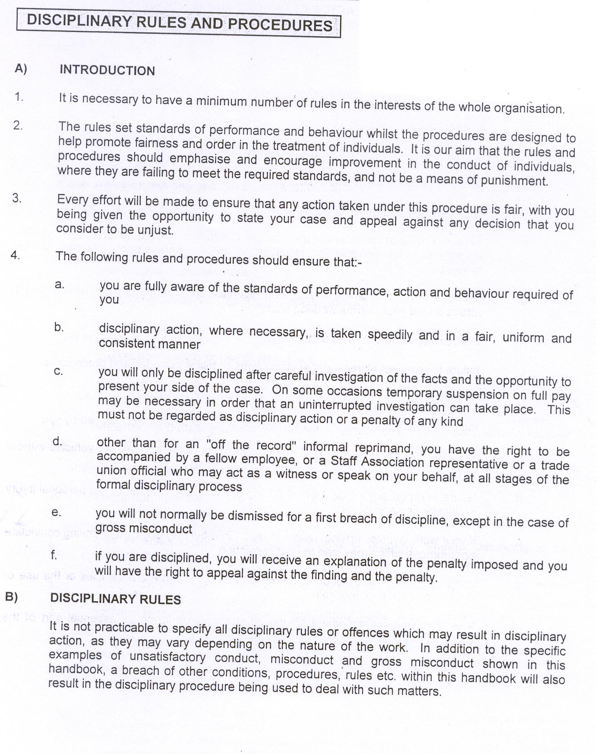
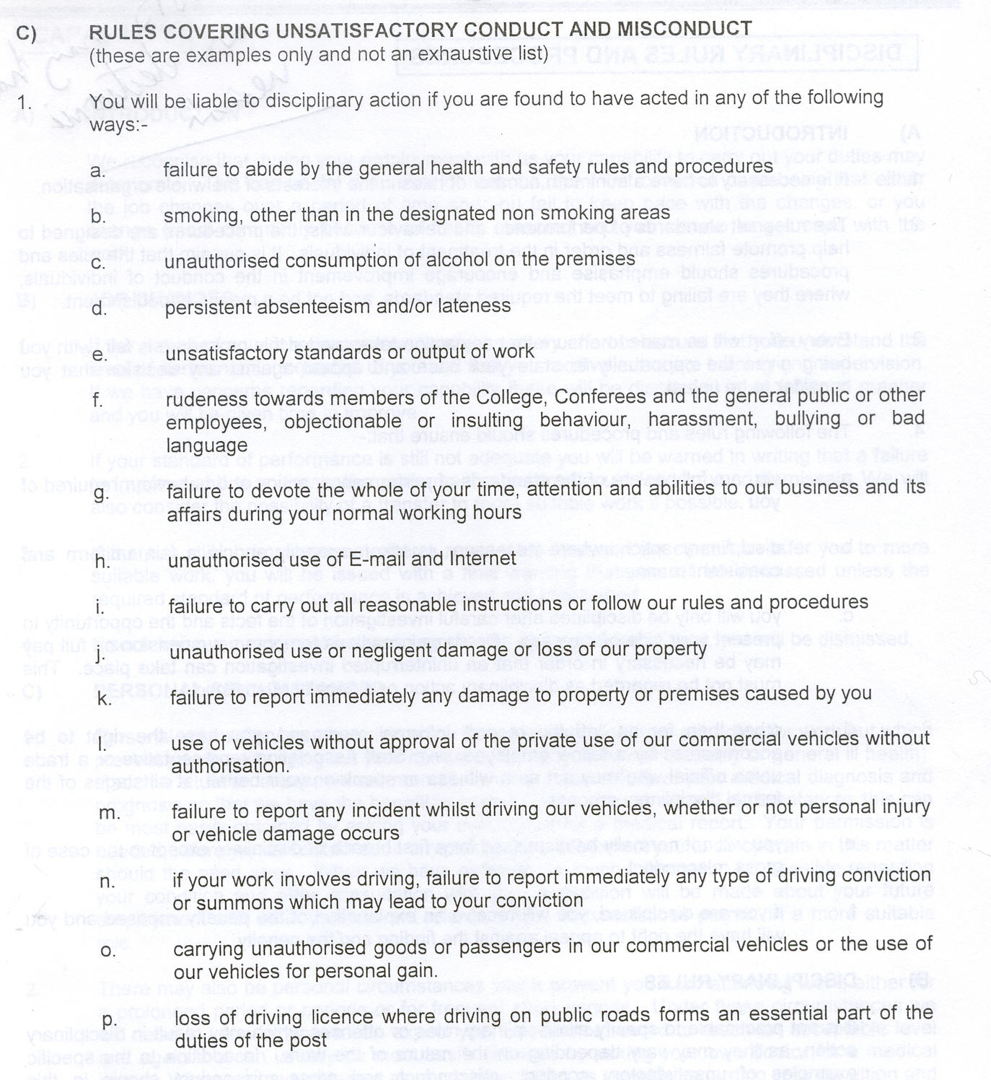
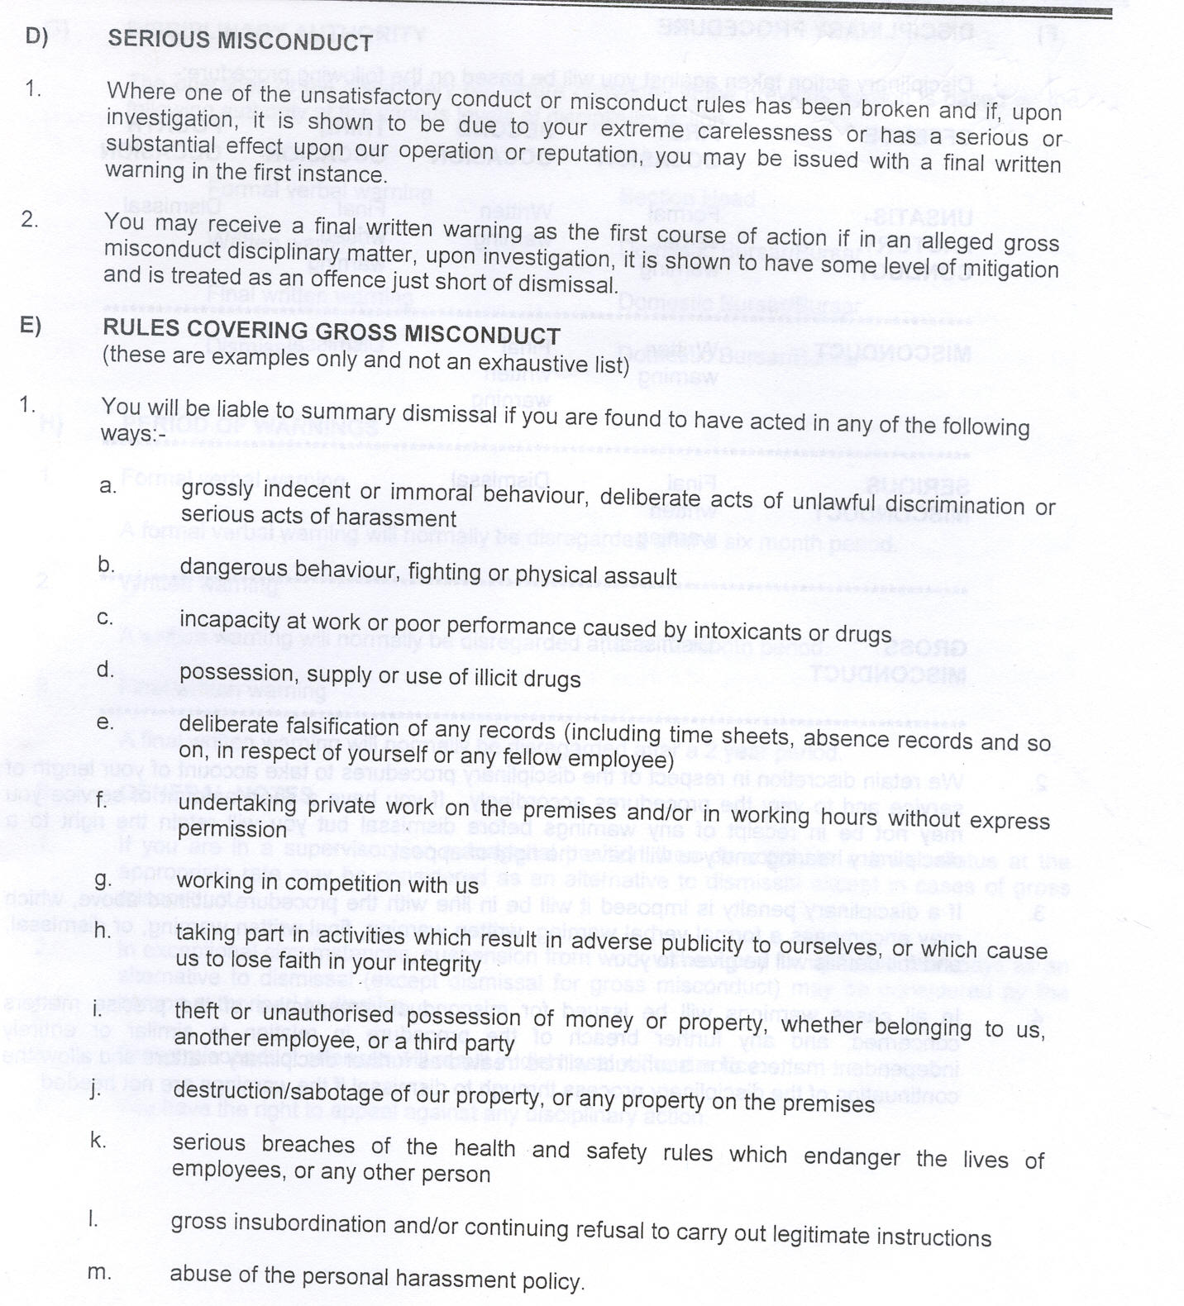
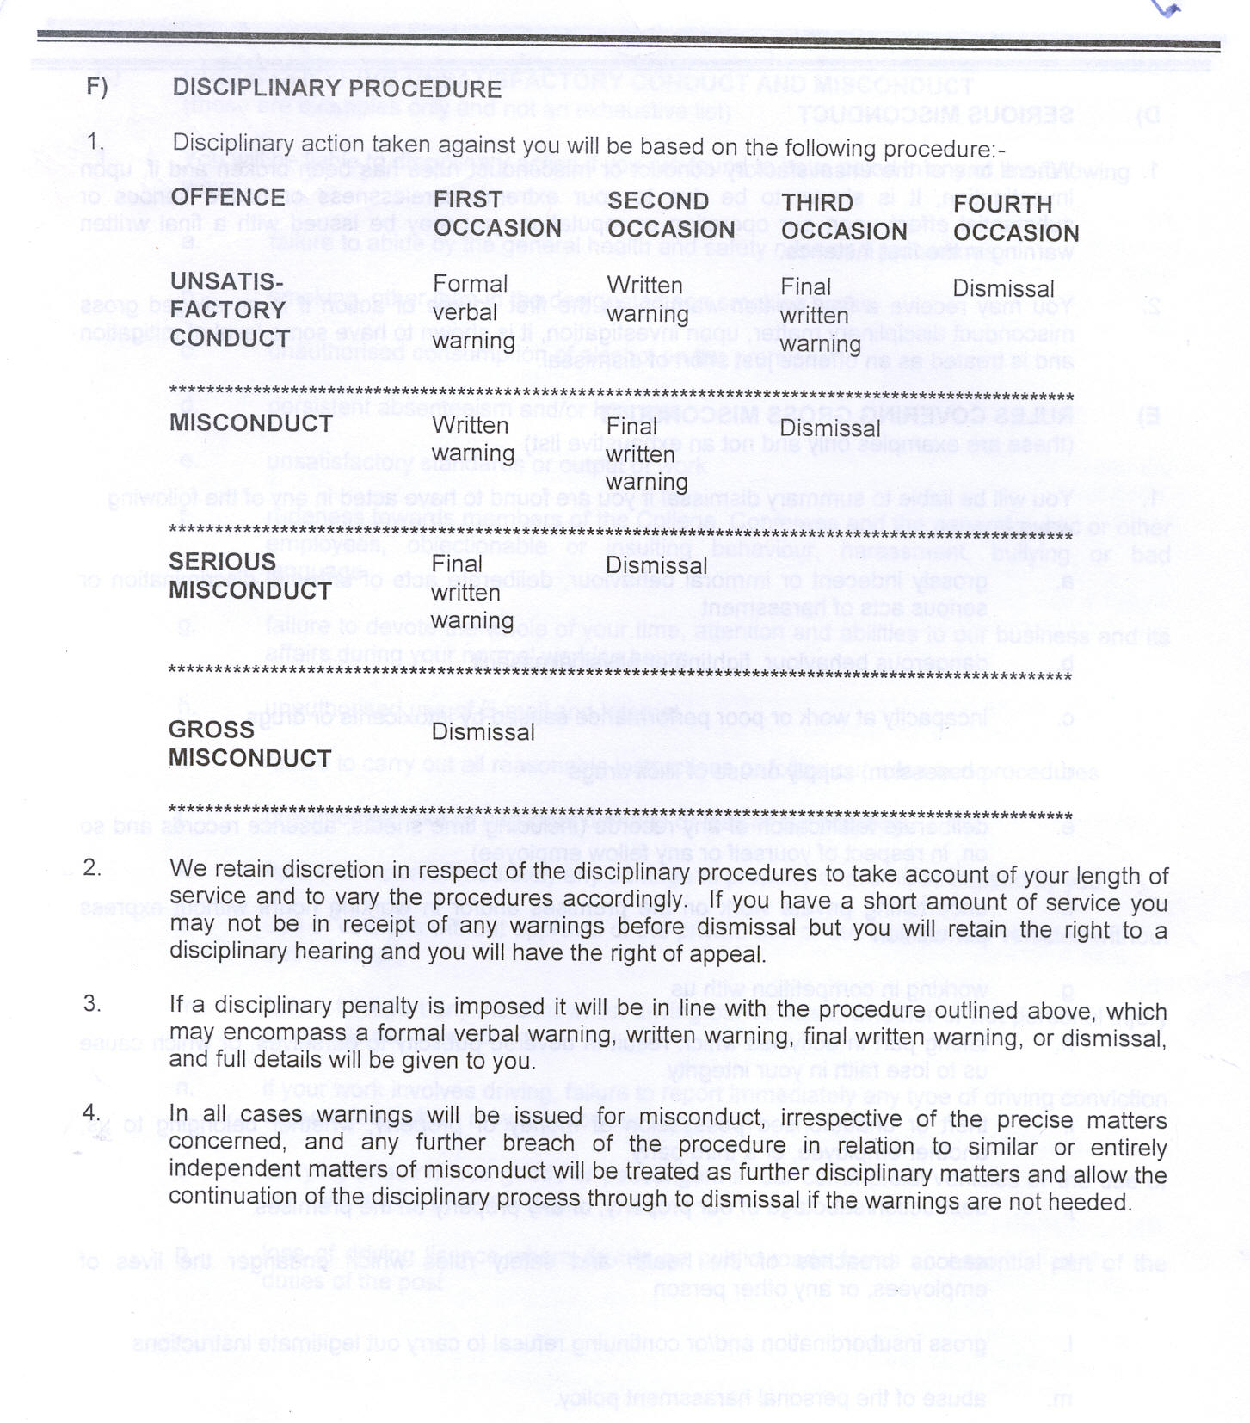
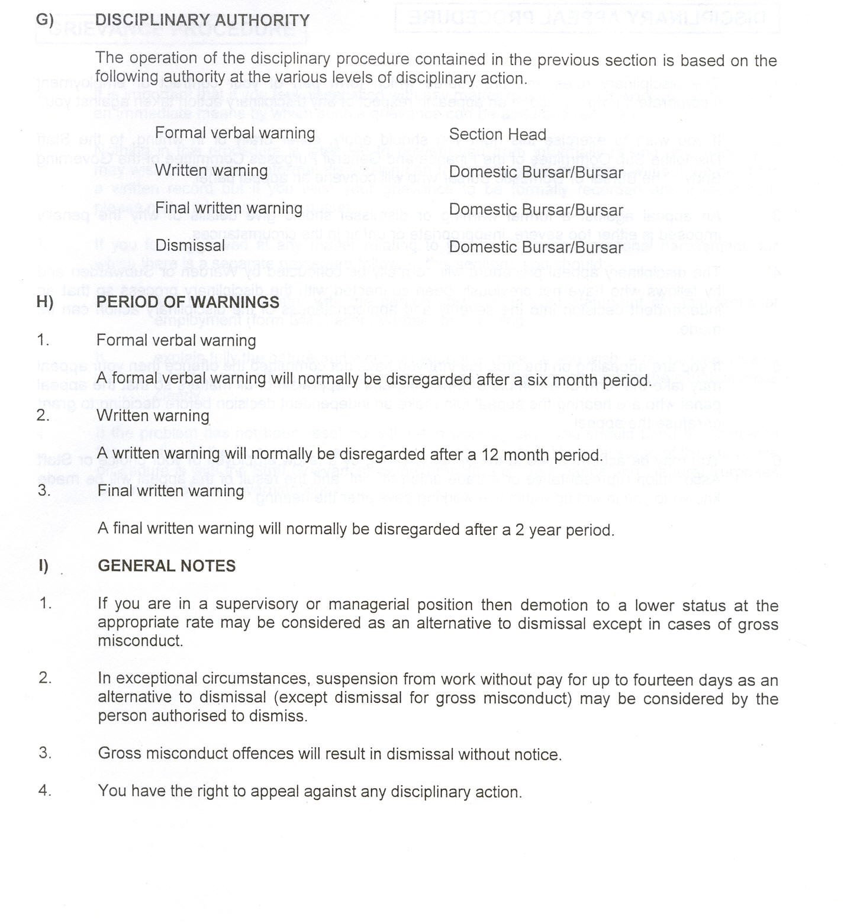
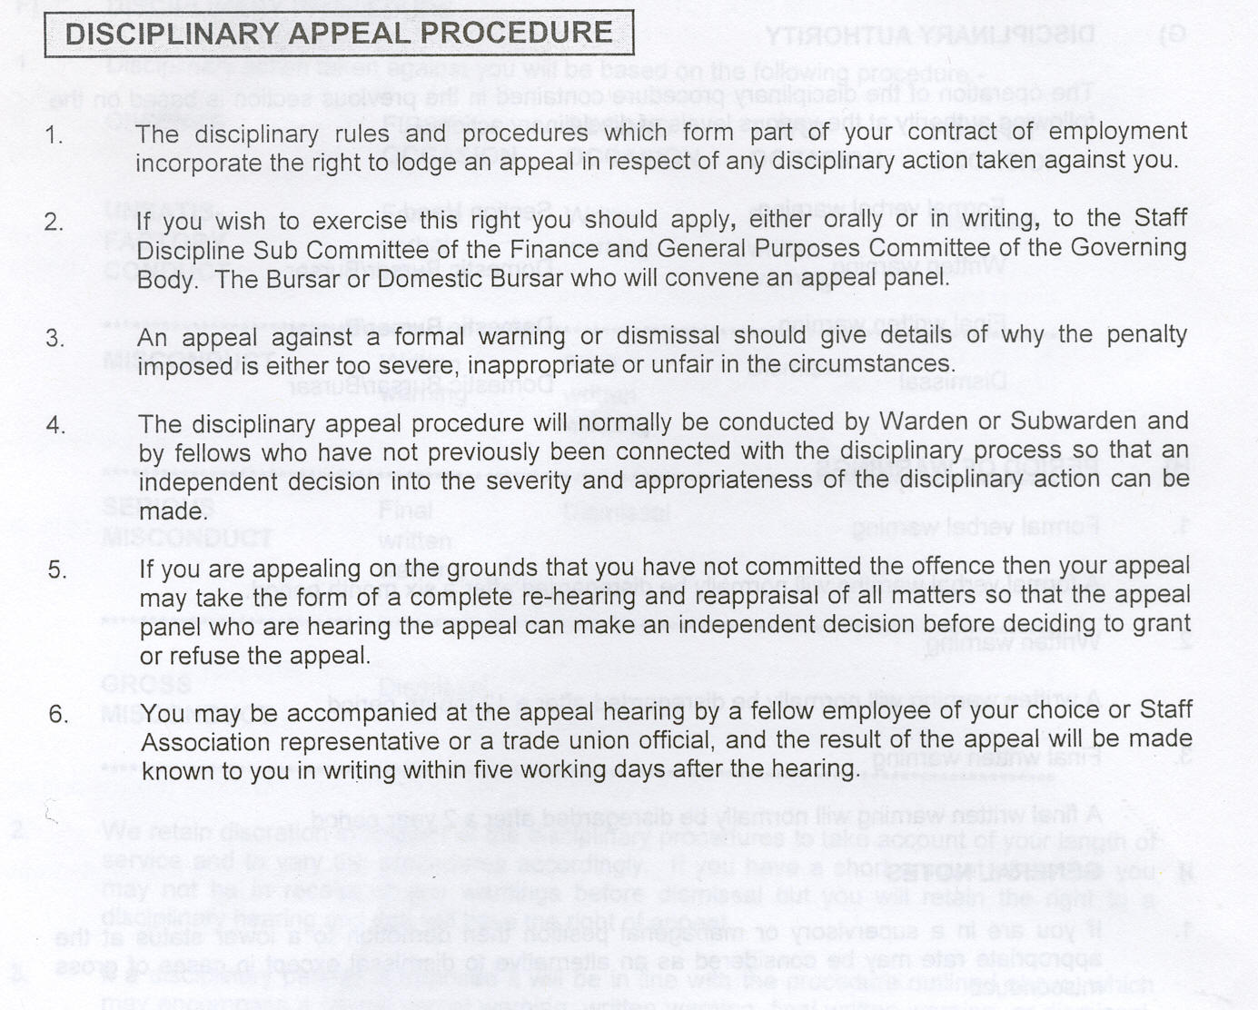

Attachment B

Disciplinary Procedure
(December 2004)
1 Purpose

  - The aim of this procedure is to help to maintain the required standards of conduct, behaviour and attendance throughout the University, and to ensure that any disciplinary action is applied consistently and fairly.

2 Scope

  - The procedure applies to all employees of the University other than the Vice-Chancellor and the Deputy Vice-Chancellors.

3 Principles

  - Disciplinary matters will be dealt with quickly and equitably.

  - No disciplinary action will be taken until the matter has been fully investigated.

  - At each stage, the employee will be advised fully of the nature of the complaint.

  - An employee has the right to be accompanied by a fellow employee, friend or trade union representative at each stage of the formal procedure. If an employee nominates a representative to support him/her through the disciplinary procedure, all correspondence will be copied to the representative.

  - No employee will be dismissed for a first breach of discipline except in the case of gross misconduct.

  - Employees have the right to appeal against any disciplinary action taken against him/her.

  - The procedure may be implemented at any stage as appropriate to the circumstances of the alleged misconduct.

  - The University’s normal disciplinary standards apply equally to trade union representatives. However, no formal disciplinary action will be taken against an employee who is an accredited Trade Union representative until the circumstances of the case have been discussed with the local senior official of the Union concerned, or the appropriate full-time regional official.

  - Standards of confidentiality will be maintained and any documentation relating to the case, including witness statements, will only be made available to those directly involved in the investigation and the disciplinary hearing(s).

  - The Director or Deputy Director of Human Resources must be kept informed of progress through all the formal stages of the disciplinary procedure and may offer advice and/or guidance to staff involved in order to maintain consistency and fairness within the procedures on behalf of the University.

  - It is a serious disciplinary offence to encourage any employee to make a misleading statement or to withhold evidence in the course of any disciplinary case.

4 Authority to take formal Disciplinary Action

  - Only Deans/Directors and their nominated deputies are authorised to initiate formal disciplinary action. Disciplinary action against a Dean or Director may be initiated by a Deputy Vice-Chancellor; disciplinary action against a Pro Vice-Chancellor may be initiated by the Vice-Chancellor or one of the Deputy Vice-Chancellors.

  - A recommendation to dismiss an employee must be approved by the Vice-Chancellor or a nominated Deputy Vice-Chancellor.

5 Addressing disciplinary issues prior to the use of the Formal Procedure

  - In cases of minor breaches of discipline, the employee’s manager will discuss their concerns with the employee.

  - The purpose of this discussion is to ensure that the employee is:
- aware of the concerns
- knows what is required to meet expected standards
- made aware of the timescale over which an improvement is required;
- made aware of the possible consequences of not achieving the required standard.

Appropriate additional action at this stage may include the provision of:
- support and training
- advice and guidance
- mentoring
- counselling
- monitoring and feedback on a pre-determined schedule
and/or an informal oral warning

  - The terms of the discussion, the outcomes and any additional actions will be confirmed in writing to the employee. Copies of this documentation should be forwarded to the link HR Manager for retention on the employee’s personnel file for the following six months. At the end of this period it will be removed.

FORMAL PROCEDURE

6 Suspension

  - An employee may be suspended by the Director or Deputy Director of Human Resources (normally the person providing advice and/or guidance as indicated in section 3.10) on standard pay during an investigation prior to a disciplinary hearing, in circumstances where the presence of the employee in the workplace during the period of the investigation might prejudice the investigation; or where there are difficulties in the relationship between the employee and other people (e.g. colleagues, students etc) with whom they would normally expect to come into contact in the workplace, which would be exacerbated by continuing to work in close proximity; or where the safety of staff and the University’s duty of care to it’s employees may be compromised by the presence of the employee at work.

  - It is important to note that:

- a suspension from duty is not a pre-judgement of guilt and is not a disciplinary penalty.
- a suspension can only be imposed (and lifted) by the Director or Deputy Director of Human Resources.
- the reasons for the suspension must be stated clearly to the employee in writing.
- the period of suspension will be as brief as possible and will be kept under weekly review.
- any restrictions on access to the University, its facilities or other employees in the workplace during the period of suspension, will be specified in the letter of notification, and any such restrictions will only be imposed in order to secure as objective and unprejudiced environment as possible for the investigation and/or to minimise potential difficulties in relationships with other people with whom they would normally expect to come into contact at work. Employees will always be entitled to contact their trade union representative during a suspension.

6.3 In circumstances where it is necessary to protect the University's interests (e.g. for reasons of safety or financial probity), and where the Director or Deputy Director of Human Resources is not available to suspend an employee, a Deputy Vice-Chancellor may instruct the employee to leave the place of work, and stay away until further notice. This will be reported to the Director or Deputy Director of Human Resources as soon as possible so that they can determine whether the employee should be formally suspended.

6.4 In exceptional circumstances, the Director or Deputy Director of Human Resources and the relevant Dean or Director may move an employee from their normal place of work during the period of the investigation in order to allow an objective investigation. The University will meet any additional transport to work costs involved in such a move.

6.5 An employee, who is suspended from work under section 6.1 or moved from their normal place of work under section 6.4, may appeal in writing, within 72 hours of receiving notice of the decision, to one of the Deputy Vice-Chancellors, with a copy of the appeal to the Director of Human Resources

7 Investigation

  - Where an issue appears to a line manager to warrant formal disciplinary action, he/she will notify the Dean/Director and the link HR Manager for the School/Directorate concerned. (For academic staff, the line manager will normally be a Head of Department or Dean of School). They will decide whether the matter should proceed to a formal investigation. This formal investigation will be carried out by the link HR Manager and the line manager, or another investigating manager appointed by the Dean or Director concerned in cases where the line manager is a key witness.

  - The employee will be informed of the decision to proceed to a formal investigation, the nature of the issues to be investigated, and their right to be supported and accompanied. The employee will be interviewed. This interview will not be a disciplinary hearing, but will be for the purpose of investigating whether a disciplinary hearing is warranted.

  - Any witnesses to incidents involved in the investigation and anyone making an allegation against the employee concerned may be interviewed. Formal written and confirmed statements will be obtained from all those interviewed. Witnesses should be informed that if the case is referred to a disciplinary hearing then they may be required to attend the hearing and give evidence based on their statements.

  - When the investigation is concluded, the investigating manager and HR Manager will decide in the light of the evidence whether:
- to take no further action
- the matter should be dealt with outside the formal disciplinary procedure
- the matter should be presented to a formal disciplinary hearing

  - If there is a disagreement the case will be referred to the Director or Deputy Director of Human Resources for determination.

  - The link HR Manager and the investigating manager, or their alternatives who have undertaken the investigation, cannot sit on the disciplinary panel. They will be expected to present the management side case at the disciplinary hearing.

  - Any Manager or other employee who has been interviewed as part of the disciplinary investigation cannot be a member of the disciplinary panel.

8 The Disciplinary Hearing

  - If it is decided that a case should be taken to a disciplinary hearing, the Director or Deputy Director of Human Resources will advise the employee, his/her representative, the line manager and the investigating manager (if they are not the same person), and the Dean/Director in writing that there will be a hearing under the terms of this procedure and a copy of the procedure will be enclosed. The letter of notification will also include:

- the date, time and venue of the disciplinary hearing, giving a minimum of five working days notice;
- the names of the panel members who will normally be the Director or Deputy Director of Human Resources (as Chair) and another Dean or Director who has had no previous involvement with the case; if the Director or Deputy Director of Human Resources has had to be involved at points 3.10 or 7.5 above, the other will be the Panel member. If the case relates to an employee in the Directorate of Human Resources, the Deputy Vice-Chancellor and Registrar (as Chair) and a Dean or Director (other than the Director of Human Resources) will form the panel.
- the nature of the allegations;
- the possible outcomes under the disciplinary procedure;
- all statements from witnesses and other relevant evidence;
- reference to the right to be accompanied by a fellow employee, friend or a trade union representative.
- An invitation to make a formal written response to the allegations, to be received by the Director of Human Resources at least two working days before the hearing.

  - The above time limits may be varied by mutual agreement. The employee may ask for the disciplinary hearing to be postponed for up to ten working days if their fellow employee, friend or trade union representative cannot attend on the date proposed. Where an initial proposed date is inconvenient for the employee and/or the representative/friend, management will offer four alternatives within the mutually agreed timescale.

  - The purpose of the disciplinary hearing is to give the employee the opportunity to respond to the findings of the investigation and to the allegations that have been made (Appendix 2).

  - The panel will take one of the following courses of action:
- dismiss the case and take no further action
- give an oral warning, if there has been a minor breach in conduct or behaviour.
- give a first written warning, if there has been an unsatisfactory response to an oral warning under this procedure, or if there has been a first but serious breach of discipline.
- give a final written warning if there has been an unsatisfactory response to previous warnings, or if there has been a first and very serious breach of discipline.
- impose a disciplinary penalty - disciplinary transfer, disciplinary suspension without pay, withholding of incremental progression, or demotion
- recommend dismissal.

  - Disciplinary action will normally progress from an oral warning to a written warning and thence to the imposition of more severe penalties. There will however be circumstances where this progression would not be appropriate and will not be followed e.g. management may decide to issue a written warning without having been through the oral warning stage, and on some occasions a first and very serious breach of discipline may warrant dismissal.

8.6 In the event of a disagreement the Chair may exercise a casting vote and the decision letter will record the area of disagreement.

9 Written Confirmation of the Decision of a Disciplinary Hearing

9.1. The Director of Human Resources or his/her nominee will inform the employee, in writing, of the decision of a disciplinary panel within five working days of the hearing. The letter will cover:
- the allegations
- any penalty that has been proposed and the reasons for the penalty
- any remedial action required of the employee and the consequences of any recurrence of misconduct, including any dates for review
- the procedure for exercising the employee’s right of appeal
- a confirmation that the warning will be disregarded for further disciplinary purposes after 6 months (for an oral warning),12 months (for a first written warning) or 24 months (for a final written warning), unless there are exceptional circumstances which justify longer or shorter periods and which are explained in the letter of confirmation.

  - Records of formal disciplinary action will be held by the Directorate of Human Resources until the end of the disregard period.

- Dismissal

10.1 If a disciplinary panel makes a recommendation for dismissal, the employee will be
notified of this recommendation in writing by the Director of Human Resources. The recommendation will be submitted to the Vice-Chancellor or the nominated Deputy, and the employee will be invited to make representations to the Vice-Chancellor, either in writing or orally before the Vice-Chancellor reaches a decision on the recommendation. The employee has five working days from the notification of the disciplinary panel’s recommendation to notify the Director of Human Resources if he/she wishes to make representations, and the representations will be made within a further ten working days from the date of the notification.

10.2 In order to come to a decision on the recommendation, the Vice-Chancellor or the nominated Deputy will receive the full set of documentation that was available to the members of the Disciplinary Panel, together with any written representations from the employee. If the employee has opted to make oral representations, they will be made through the procedure set out in Appendix 3. The Vice-Chancellor may seek supplementary information from any of the parties, and any such information shall also be communicated to the employee and the Director of Human Resources.

10.3 If the recommendation for dismissal is approved, the employee will be notified and informed of the right of appeal. If an appeal is lodged the dismissal does not take effect until the appeal has been heard, but the employee will be suspended without pay from the date of the letter of notification of the Vice-Chancellor’s decision. In the event of a successful appeal any pay that has been withheld will be reinstated.

11. Appeals

  - An employee has a right of appeal against a decision made under the formal Disciplinary Procedure.

  - The right of appeal must be exercised within 10 working days of receipt of the letter of confirmation of disciplinary action.

  - The appeal, stating the grounds on which it is made, should be sent in writing to the Director of Human Resources.

  - An appeal against an oral, first or final written warning, or a disciplinary penalty, will be heard by one of the Deputy Vice Chancellors (provided he/she has not previously been involved in the case).

  - An appeal against a decision by the Vice-Chancellor to dismiss will be heard by the Appeals Committee of the Board of Governors, which will consist of 3 independent Governors of the University appointed by the Chair. Decisions made on appeal shall be final and the employee will be informed in writing within five days after the appeal hearing.
(Appendix 4)

  - The University will hear any appeal within 20 working days of the appeal being lodged, unless otherwise agreed in writing between the parties.

  - The decision of the appropriate appeal body (communicated in writing to the employee) shall be final within the procedures of the University.

  - In all cases of appeal the employee may appear in person and with a fellow employee, friend or a trade union representative.

Appendix 1

The following list indicates the categories of misconduct that might result in formal disciplinary action, including summary dismissal, in certain circumstances. They are not exhaustive.

Misconduct

The following examples of behaviour may, within this procedure, lead to a disciplinary warning and, if repeated, to dismissal:

- unjustifiable absence
- poor time-keeping
- failure to observe safety regulations
- misuse of University property
- behaviour which is likely to bring the University into disrepute (subject, always, to any relevant contractual conditions relating to academic freedom and the provisions of the whistleblowing procedure)
- aggressive or offensive behaviour
- breach of trust and confidence
- refusal to follow a reasonable management instruction
- failure to comply with University policies

Gross misconduct

The following examples of behaviour at work may be regarded as gross misconduct, and, may lead to dismissal without notice and without pay in lieu of notice:

- taking any detrimental action against a member of staff for exercising any rights under this or any other University procedure
- dishonesty, theft, fraud, deliberate falsification of records or misuse of University property, including malicious damage to University property
- theft from or violence to other members of the University or members of the public including malicious damage to their property
- obscene or indecent behaviour or sexual misconduct or the circulation of offensive material
- serious aggressive or offensive behaviour
- any form of discrimination which is unlawful and/or conflicts with the University’s policies and procedures
- serious breach of security or of financial procedures
- serious breach of trust and confidence
- incapability whilst on duty brought on by alcohol or illegal drugs
- being in the possession of illegal drugs in the workplace
- severe breach of health, safety and hygiene rules or acting in a manner dangerous to others
- behaviour bringing University into serious disrepute (subject, always, to any relevant contractual conditions relating to academic freedom and the provisions of the whistleblowing procedure)
- professional incompetence or gross negligence

Note: Forms of serious misconduct outside the workplace may lead to disciplinary action where it is considered there is an effect upon the employment relationship.

Appendix 2

Procedure for Disciplinary hearing

1. One or other of the HR Manager and the investigating manager who have conducted the investigation will present the management case and will identify the witnesses that he/she intends to call. The other investigator may make any additional points that are relevant to the case.
N.B. - The only evidence admissible under the Disciplinary Procedure is evidence from an identified individual regarding matters of which they have first-hand experience. Hearsay evidence is not acceptable, whatever its source. Individuals who have provided evidence must be available to answer questions if required. In circumstances where witnesses are prevented by factors beyond their control from being present, either their evidence may be dispensed with by the party who requested them to give evidence or the hearing will be adjourned until they become available.

- the employee is entitled to know who is to be called as a witness at least 3 working days before the hearing.

2. The investigators’ witnesses will then be questioned by the presenting manager and subsequently by the employee or his/her representative

3. Members of the panel may ask questions of the witnesses and of the presenting manager.

4. The employee or his/her representative will present the employee’s case and indicate any witnesses who he/she intends to call. (N.B. the investigating managers are entitled to know who is to be called as a witness at least 3 working days before the hearing).

5. The witnesses will then be questioned by the employee or his/her representative and subsequently by the investigating managers.

6. The employee or his/her representative may question the presenting manager.

7. Members of the panel may ask questions of the witnesses and the employee.

8. The presenting manager will summarise the management case.

9. The employee or his/her representative will summarise the employee’s case.

10. The Panel will deliberate in private and will let all parties know their decision within 5 working days.

Guidance notes:

1. A hearing may be adjourned by the Chair if new evidence is introduced and one or both sides request an adjournment to consider how to respond.

2. Witnesses may be re-called by the Chair if one side or another requests the right to ask additional questions.

Witnesses will only be present when they are giving evidence and will normally be interviewed individually.

Appendix 3

Procedure for making oral representations to the Vice-Chancellor against a recommendation for dismissal

The employee will have up to 30 minutes to make representations to the Vice-Chancellor, supplementing or supporting the information covered in the written documentation provided from the disciplinary hearing.

The Vice-Chancellor may ask whatever additional questions he thinks are necessary to obtain a sufficiently sound basis for making a decision to confirm or turn down the recommendation for dismissal.

The Chair of the disciplinary panel shall be invited to attend and may be invited by the Vice Chancellor to clarify any point arising from the written documentation or oral representations.

Appendix 4

Appeal to the Board of Governors at the final stage of the Disciplinary Procedure

1. The Appeals Committee shall consist of three independent Governors of the University appointed by the Chair, who may be one of the three.

2. A senior member of University staff, who has not previously been involved in the case, will act as Secretary to the Committee.

3. Procedure

(i) The Chair of the Disciplinary Panel will present the findings of the Panel and the reasons for the Panel’s recommendations.

(ii) The appellant, or his/her representative, will then have the opportunity to present their case and may present further written documentation in support.

- The members of the Committee may ask questions of the Chair of the Panel and the appellant to satisfy themselves as to the facts of the case and the interpretation to be placed upon them.

- The Chair of the Panel and the appellant (in that order) may make final submissions, summing up their case. They shall not introduce new evidence at this stage.

- The committee will deliberate in private and will inform the appellant and the Director of Human Resources, in writing, of their decision within 5 working days.

- If significant new evidence comes to light in the course of the hearing, the Committee may instruct the Director of Human Resources to arrange a re-hearing of the case by a differently constituted Disciplinary Panel. This shall take place within 15 working days of the instruction being received by the Director.

5. If the employee is unable to attend an appeal hearing, the Committee will normally seek to set another mutually convenient date, but may decide, taking account of all the circumstances, to proceed in the employee’s absence.

Attachment C

UUK and UCEA
Approved by the Privy Council

Final Draft [as submitted to the Privy Council Office]/Revision 1
1 March 200218 June 2002

DRAFT REVISED MODEL STATUTE

STATUTE XX
Academic Staff: Dismissal, Discipline, Grievance Procedures
and related matters

PART I: GENERAL

- Application

- This Statute applies to the following:

- the members of the academic staff (except for those excluded from Part II by clause 5(1) below);
- such other members of staff or categories of staff of the University as are brought within its scope by the Council;

and “member(s) of staff” in this Statute means those members of the staff to whom this Statute applies.

- This Statute will override any provision in any contract, term or condition of employment which is inconsistent with this Statute, whether dated before or after the commencement of this Statute, but –

- it shall not affect the validity of any waiver under section 197 of the Employment Rights Act 1996, any compromise agreement under section 203 of the Employment Rights Act 1996, or any similar waiver or agreement permitted by law; and
- it shall not preclude any member of staff deciding or agreeing to terminate employment with the University, whether by voluntary severance, early retirement or otherwise, on whatever terms have been agreed.

- Parts II to V of this Statute shall not apply to removal from an appointment as Pro-Vice-Chancellor, Dean or Head of Department, or such other posts as have been designated by the Council, to which a member of staff has been elected or appointed and which is distinct from that individual’s substantive post, where dismissal from the substantive post is not contemplated, but the Council shall by Ordinance prescribe a procedure for handling such removals prior to the prescribed or normal termination date, which shall include a hearing panel and an appeal panel.

- This Statute shall not apply to the Vice-Chancellor, except for Part III, which shall, unless the Council, with the Vice-Chancellor’s concurrence, resolves otherwise, apply to the Vice-Chancellor in post at the time it comes into effect, with such modifications and adaptations as the Council, with the Vice-Chancellor’s concurrence, shall prescribe, but it shall not apply to any later Vice-Chancellor, even if also the holder of an academic post.

- General principles of construction and application

- This Statute and any Ordinances or Regulations made under it shall be applied and construed in every case to give effect to the following guiding principles:

- to ensure that members of staff have freedom within the law to question and test received wisdom, and to put forward new ideas and controversial or unpopular opinions, without placing themselves in jeopardy of losing their jobs or privileges;
- to enable the University to provide education, promote learning and engage in research efficiently and economically; and
- to apply the principles of justice and fairness.

- Where, in any proceedings under this Statute, a member of staff invokes sub-clause (1)(i) above, that claim shall be considered by the person or persons dealing with the matter, and, if it is found that any action has been taken against the member of staff because that member of staff questioned or tested received wisdom or put forward new ideas or controversial opinions, the person or persons dealing with the matter shall cancel that action and it shall be treated as invalid.

- Where there is any issue as to the meaning of “academic freedom” in any proceedings under Parts II, III, IV, V and VI of this Statute, regard shall be had to Sections VI and VII of the Recommendation concerning the Status of Higher-Education Teaching Personnel adopted by the General Conference of the United Nations Educational, Scientific and Cultural Organisation (UNESCO) in Paris on 11 November 1997.

- Any reference in this Statute to a provision in an Act of Parliament shall be taken to be a reference to that provision as it may have been amended or superseded from time to time.

- In interpreting or construing any provision in this Statute, regard shall be had to the Notes on Clauses on the Draft Revised Model Statute issued by the Universities and Colleges Employers Association (xxxx 2002).

- Dismissal

(1) For the purpose of this Statute, “dismissal” shall have the same meaning as in section 95 of the Employment Rights Act 1996.

- A member of staff may be dismissed if that dismissal is for a reason set out in section 98 of the Employment Rights Act 1996.

- (i) A dismissal by reason of redundancy (other than the non-renewal of a fixed-term contract) shall be handled in accordance with Part II;
- a dismissal for disciplinary reasons shall be handled in accordance with Part III;
- a dismissal on health grounds shall be handled in accordance with Part IV; and
- a dismissal on any other grounds, including the non-renewal of a fixed-term contract, shall be handled in accordance with Part V.

- Hearing, appeal and grievance panels

- Any panel established pursuant to clauses 8(1), 10(ii)(d) and (g), 15(2), 18(2) and 20(5) of this Statute shall consist of three persons, none of whom shall previously have had any involvement with the case, at least one of whom shall be a lay member of Council and one a member drawn from a list agreed from time to time by the Senate.

- Ordinances may provide for any relevant National Health Service or other relevant body to be represented on any panel established under this Statute to deal with a member of staff falling within clause 19(1) below and for the panel to be enlarged for this purpose.

- At any panel within sub-clause (1) above, the member of staff shall be entitled to be represented or assisted by any person.

- Any panel within sub-clause (1) above shall give a reasoned decision in writing which shall be provided to the member of staff and reported to the Council.

PART II: REDUNDANCY

- Application

- The power to dismiss, and the procedures prescribed, under this Part shall not apply to those staff defined in sub-sections (3) to (6) of section 204 of the Education Reform Act 1988 [staff appointed prior to, and not promoted after, 20 November 1987], who shall for this purpose continue to be subject to such powers, if any, as applied to them prior to the introduction of the Statute made by the University Commissioners in the exercise of their powers under sections 203 and 204 of the Education Reform Act 1988.

- This Part shall not apply to the non-renewal of a fixed-term contract, which shall be dealt with under clause 16 below.

- Definition of “redundancy”

Subject to clause 5(2) above, dismissal by reason of redundancy for the purpose of this Part has the same meaning as in section 139 of the Employment Rights Act 1996.

- Procedure for dismissal by reason of redundancy

- The Council shall by Ordinance prescribe the procedures for dismissing members of staff on grounds of redundancy, which shall include the following:

- a preliminary stage involving consultation with appropriate representatives in accordance with and to the extent required by section 188 of the Trade Union and Labour Relations (Consolidation) Act 1992 and discussion with the staff concerned;
- a procedure which is fair and which allows each staff member concerned, having been informed of the selection criteria to be employed, to make written and oral representations on his or her behalf;
- provision for informing any member of staff dismissed under this Part of the reasons for the dismissal and, where selection has taken place, why he or she was selected; and
- authorising the Vice-Chancellor or other person to dismiss any member of staff selected for dismissal under this Part and requiring reports of dismissals to be submitted to the Council.

- The procedures following the preliminary stage may be used at any particular time only after the Council has first determined that the circumstances are such that the procedures should be instituted.

- Appeal against dismissal by reason of redundancy

- The Ordinances shall include provision for an appeal to a panel by a member of staff who has been given notice of dismissal under this Part.

- The panel shall be entitled to review all aspects of the matter other than the Council’s determination under clause 7(2) above.

- The panel shall have the power to reach a final decision on the matter or to remit the matter for further consideration by the body whose decision is being appealed.

PART III: DISCIPLINARY PROCEDURES

9. Grounds for disciplinary action

Disciplinary action under this Part may be taken, and where found to be appropriate a penalty imposed, in respect of the following:

- conduct amounting to a criminal offence, whether or not there has been a prosecution and conviction, of a kind that is judged in all the circumstances to be relevant to the member of staff’s employment by the University;
- failure, refusal, neglect or inability to perform some or all of the duties or to comply with some or all of the conditions attaching to the post, or performing those duties or complying with those conditions in an unsatisfactory or inadequate manner;
- conduct of a kind judged to be inappropriate or unacceptable on the part of a holder of the post held by the member of staff, such as (but not confined to) the following:

- breach of any obligation or duty arising under any of the University’s regulations regarding financial matters, harassment, equal opportunities, public interest disclosure, health and safety, or data protection or any other rules, regulations or codes binding on the member of staff;
- damage to or improper use of University facilities, premises, property or equipment;
- disruption of, or improper interference with, the activities of the University or of any employee, student, Council member or visitor (other than any lawful industrial action);
- violent, indecent, disorderly, threatening, abusive, insulting or harassing behaviour or language (whether written, spoken or in any other form);
- fraud, deceit, deception or dishonesty in relation to the University or any related activity, including research and examining;
- action likely to cause injury or impair safety;
- divulging information or material received in confidence (unless the disclosure is permitted under the Public Interest Disclosure Act 1998 or in accordance with the University’s Public Interest Disclosure Procedure).

- Disciplinary procedures

The Council shall by Ordinance promulgate disciplinary procedures for members of staff, which shall provide:

- for less serious matters to be dealt with by warnings following a fair and appropriate procedure and for a member of staff to be able to appeal against the imposition of a warning to a person designated by the Vice-Chancellor; and
(ii) for dealing with more serious matters, which shall include provision for the following:

- fair and reasonable time limits for each stage;
- investigating complaints and dismissing those found to be without substance;
(c) suspension, on full pay, by the Vice-Chancellor pending an investigation or hearing where this is necessary;
- a hearing by a panel, authorised by the Vice-Chancellor, at which the member of staff against whom the complaint has been made shall have been informed of the complaint, shall be entitled to be present, to hear the evidence, to call relevant witnesses, and to examine and cross-examine witnesses (but provision may be made for witnesses in appropriate cases to give their evidence behind a screen or from another room or place and for questions to be asked only by a representative);
- appropriate penalties, which in addition to warnings and dismissal shall, for staff appointed or promoted after the coming into effect of this Statute, include withholding any forthcoming increment in salary, suspension without pay (for up to three months), and reduction in grade and/or loss of title (and “promoted” for the purpose of this provision shall have the same meaning as in section 204 of the Education Reform Act 1988);
- the award of compensation either to the University or to an individual in respect of any loss caused or damage done;
- designating a member of staff’s conduct as constituting “gross misconduct” such as to merit summary dismissal without notice; and
- a right to appeal against the finding of, or penalty imposed by, the panel, including a finding under paragraph (g) above. An appeal shall not take the form of a re-hearing of the evidence and witnesses may be called only with the appeal panel’s permission.

- Code of Practice

In drawing up the procedures, and in any regulations made or action taken thereunder, regard shall be had to Section 1 of the Code of Practice on Disciplinary and Grievance Procedures (as may be amended or replaced from time to time) issued in September 2000 by the Advisory Conciliation and Arbitration Service (ACAS) and brought into effect by order of the Secretary of State under section 199 of the Trade Union and Labour Relations (Consultation) Act 1992.

- Dismissal

- The Secretary/Registrar or other designated officer shall give effect to a decision of a panel that a member of staff should be dismissed:

- where the panel has designated the conduct as “gross misconduct” such as to merit summary dismissal pursuant to clause 10(ii)(g), the Secretary/Registrar shall forthwith dismiss the member of staff;
(ii) in all other cases, the Secretary/Registrar shall issue the notice of dismissal or dismiss together with payment in lieu of notice.

(2) Any dismissal or notice of dismissal shall be cancelled, withdrawn or modified if an appeal panel decides that the member of staff should not be dismissed or should only be dismissed with notice.

13. Relationship with Part IV

The Ordinances shall make provision for dealing with a case in progress under this Part where it emerges that the member of staff’s conduct or performance may have been wholly or partly attributable to a medical condition, but any proceedings under this Part shall be valid even if notwithstanding that they could have been brought under Part IV, and a member of staff may, subject to the Disability Discrimination Act 1995, be subject to penalty, including dismissal, under this Part notwithstanding the fact that his or her conduct may have been wholly or partly attributable to a medical condition.

14. Clinical staff

Action under this Part or under Part IV may be taken against a member of staff falling within clause 19(1) below in respect of conduct or incapacity arising in connection with that member of staff’s clinical work or activities as if the work or the activities were performed in and for the University.

PART IV: INCAPACITY ON HEALTH GROUNDS

- Dismissal on health grounds

- The Council shall by Ordinance prescribe a procedure for dismissing dealing with staff, including dismissal, because of incapacity on health grounds, whether physical or mental.

- The procedure shall include a hearing by a panel, with a right of appeal to another panel, and both panels shall contain an appropriately medically qualified person.

- No member of staff may be dismissed whether under this Part or Part III where that dismissal would contravene the Disability Discrimination Act 1995.

PART V: OTHER DISMISSALS

16. Non-renewal of a fixed-term contract

- The Vice-Chancellor, or other person or persons designated by the Vice-Chancellor, shall in every case where a fixed-term contract is due to terminate consider whether that contract should be renewed or extended or a contract of indefinite duration should be offered, having consulted the appropriate representatives in accordance with and to the extent required by section 188 of the Trade Union and Labour Relations (Consolidation) Act 1992 and having given an opportunity to the member of staff to make representations.

- A decision not to renew or extend or offer a contract of indefinite duration under the preceding paragraph must be justified on the basis that, in respect of one or more of the following considerations, it is not expedient or desirable to renew or extend the contract or offer a contract of indefinite duration:

- the availability of funding for the post, or the financial situation;
- the individual’s performance (following appropriate warnings and counselling);
- the need for the post or the duties attaching to the post;
- the nature and character of the post;
- the desirability of making the post permanent and appointing to it after open competition.

- A member of staff whose fixed-term contract is not renewed or extended on termination or is not offered a contract of indefinite duration shall be given full reasons for the decision and shall be entitled to have the decision reviewed by a panel in accordance with a procedure to be prescribed by Ordinance.

- The panel, whose decision shall be final, shall consider whether the reasons advanced in support of the decision are reasonable and supportable.

- Probationary appointments

- This Part shall also apply to members of staff who have been appointed subject to review after a period of probationary service.

- The Council shall by Ordinance prescribe a procedure under which staff on probation shall be reviewed and shall include provision for non-confirmation in post at the end of the probationary period if their performance is found to be deficient or for any other substantial reason or reasons they are judged unsuitable to be confirmed in post.

- The review referred to in sub-clause (2) may encompass matters which, in other circumstances, would fall to be dealt with under Parts II, III or IV of this Statute.

- The substance of sub-clauses (3) and (4) of clause 16 shall apply to a member of staff who has not been confirmed in post under this clause.

18. Dismissal on other grounds

(1) This clause covers dismissals on any ground falling within clause 3(2) other than those covered by Parts II, III, IV and clauses 16 and 17 of Part V of this Statute (i.e. “some other substantial reason of a kind such as to justify the dismissal of an employee holding the position which the employee held” (Employment Rights Act 1996, s. 98(1)(b); “the employee could not continue to work in the position which he held without contravention (either on his part or on that of his employer) of a duty or restriction imposed by or under an enactment” (s. 98 (2)(d)).

- Dismissals covered by sub-clause (1) above shall be handled in accordance with a procedure prescribed by Ordinance, which shall include the right to be heard by a panel and the right to appeal to a panel.

19. Clinical staff

- This clause applies to a member of the clinical academic staff who is required to engage in clinical work or activities and for that purpose to be registered with the General Medical or Dental Council or similar body and/or to have an honorary or substantive contract or status with a National Health Service trust or similar body, and may by Ordinance be extended to other groups of staff in a similar situation.

- Where the registration, contract or status referred to in sub-clause (1) above is terminated, withdrawn or revoked, the Vice-Chancellor may, having first afforded an opportunity to the member of staff concerned to make representations, dismiss the member of staff concerned; and where the registration, contract or status is suspended, the Vice-Chancellor may suspend the member of staff from employment for so long as the registration, contract or status is suspended, that suspension from employment to be without pay where the registration, contract or status has been suspended as a substantive disciplinary measure.

PART VI: GRIEVANCE PROCEDURES

- Grievance Procedure

- The Council shall by Ordinance promulgate a Grievance Procedure for members of staff and in doing so shall have regard to Section 2 of the Code of Practice (as may be amended or replaced from time to time) referred to in clause 11 above.

- The Procedure shall apply to grievances by members of staff concerning their appointments or employment in relation to matters affecting themselves as individuals or their personal dealings or relationships with other staff of the University, other than those for which provision is made elsewhere in this Statute or in respect of the outcome of any matter dealt with under this Statute, or where the Council has prescribed other procedures, provided those other procedures are no less favourable to the individual than under the Grievance Procedure.

- The Procedure shall provide that consideration of a complaint under the Procedure may be deferred if other proceedings under this Statute concerning the individual and relevant to the application are pending or in progress.

- The Procedure shall provide for the fair and speedy resolution of complaints, informally wherever possible, and for the complainant to be entitled to be assisted by any other member of staff or by a trade union representative at any hearings prior to that under sub-clause (5) below.

- The Procedure shall make provision for a member of staff who is dissatisfied with the outcome of a complaint to be able to have the complaint heard by a Grievance Panel unless the complaint has been ruled frivolous, vexatious or invalid in accordance with the Procedure.

March 18 June 2002

D

CAPABILITY PROCEDURE
(7th DRAFT December 2004)

1. Purpose

1.1 This procedure is designed to support staff and managers in dealing with problems of poor performance which may arise from time to time. It aims to:

- ensure that any concerns about an employee’s ability to achieve acceptable standards of work are addressed effectively through a clear and supportive procedure
- ensure that supervision, training, counselling and support measures are deployed appropriately to help employees to achieve acceptable standards of work
- provide a clear procedure for the termination of employment in cases where it does not prove possible to secure a satisfactory and acceptable level of performance

1.2 Where poor performance is due to a failure to maintain adequate standards of behaviour rather than a lack of skills or application, it should be dealt with through the disciplinary procedure. Capability is defined for the purposes of this procedure as all matters related to an employee’s skills, aptitudes or competences and their application.

  - Where poor performance is linked partly or wholly to a qualifying disability under the Disability Discrimination Act, the requirements of that Act for reasonable adjustments to the workplace or the job will be taken into account. Where poor performance is linked partly or wholly to medical problems, the University’s procedures for dealing with absence from work due to ill-health should be used as appropriate.

1.4 This procedure applies to all employees of the University, other than the Vice-Chancellor and the Deputy Vice-Chancellors.

2. General Provisions

  - Setting performance standards:

Employees have a contractual responsibility to achieve an acceptable level of performance at work, and will be supported and encouraged to reach that level. Managers should set realistic and achievable standards consistent with the employee’s contract and the university’s policy on academic workload planning. These should ensure that employees understand what those standards imply in terms of the quality and quantity of work and the time and costs associated with the expected outputs. Any shortfalls in performance should be discussed promptly with the employee concerned, and the causes of the shortfall identified. Consideration should be given to whether it is due to inadequate training, supervision or guidance, and if appropriate, measures should be taken to provide additional support.

  - Employee induction:

New employees must receive a structured induction to the University and to their job and immediate workplace, which is consistent with the framework for staff induction provided in the Staff Handbook. This framework seeks to ensure a good basic introduction to the University in the following areas:

- Organisational Information: The structure and objectives of the School/Directorate, the main administrative processes affecting staff (particularly procedures for booking leave, reporting absences and obtaining personnel information), the layout of the building and site where the employee is located, health and safety procedures, use of the PC and the Intranet, making and taking personal phone calls and ordering stationery.

- Job-related information: The duties and responsibilities of the post, the standards of work expected and lines of reporting/responsibility, procedure manuals or desk instructions, the Personal Development and Review system and objective setting, hours of work and how to identify and apply for training and development opportunities.

2.3 During the first six to nine months of employment, the line manager must hold regular meetings with a new employee to review progress and to identify any weaknesses and development needs. Where performance problems are identified, appropriate measures to address them should be discussed with the employee as quickly as possible.

3. Personal Development and Review

3.1 The University has established a structured approach to personal review which operates on an annual cycle. New employees should be given appropriate targets and support training on a shorter time scale, such that managers and employees alike can be satisfied that adequate progress is being made towards the expected performance levels.

4. Principles of the Capability Procedure

4.1 Problems of poor performance should be dealt with promptly and equitably.

4.2 At each point in the procedure, the employee will be given a full explanation of the perceived weaknesses or deficiencies in performance.

4.3 An employee has the right to be accompanied by a fellow employee, friend or trade union representative at each stage of the formal procedure.

4.4 Documentation relating to the use of this procedure will be treated as confidential and will only be made available to those directly involved.

4.5 The Director or Deputy Director of Human Resources will be informed about the progress of any case which reaches the formal procedure and may offer advice and/or guidance in order to maintain consistency and fairness in the application of the regulations.

4.6 In cases where capability is affected by ill health and the employee does not wish to take sick leave, they should advise their line manager of the health problem. The line manager should consider whether it is possible to adjust the employee’s workload and/or working conditions in the light of these problems.

Throughout the procedure, the work of the employee will be considered in the light of any adjustments that have been agreed by their manager.

If an employee is unable by reason of ill health to perform their duties satisfactorily, allowing for any adjustments that may have been agreed with their manager, they are required to take sick leave. Presenting themselves for work commits the employee to performing their duties to an acceptable standard.

5. Dealing Informally With Issues of Capability

5.1 When a manager has concerns about the performance of a member of staff, they may wish initially to consult more senior colleagues and the link Human Resources Manager about the most appropriate means of dealing with the perceived problem.

5.2 The manager will then:

- let the employee know the nature of the perceived problems and the date and time of a meeting to discuss how they should be addressed.
- at that meeting, explain why the expected standards of performance do not appear to have been met, and identify occasions when deficiencies have occurred.
- endeavour to establish the reasons for the unsatisfactory level of performance, taking account of all the factors which might have had an effect on the employee’s performance, including the volume of work, the available resources, training, personal matters, ill health and changes in management or working practices.
- the employee’s views and perception of all the matters involved should be taken fully into account, and any additional or alternative evidence considered in good faith.
- seek to establish an agreed programme to address the problems, which may involve additional supervisory support, further training, additional resources, organisational changes, changes to workload, or where a personal issue is identified, counselling or a period of special leave. A clear monitoring and feedback review procedure must also be agreed.

5.3 Before agreeing a programme of action, the employee may wish to consult with a trade union representative or a friend. The manager and the employee may agree mutually to involve others in reaching a mediated agreement on a programme of action.

5.4 A programme of remedial action should set targets and dates for meeting objectives a competent holder of the post could reasonably be expected to meet. For most administrative and organisational issues, targets of between one week and three months duration will be the norm, but the nature of academic work patterns and job requirements are such that longer–term targets may need to be set. The consequences of not meeting the required standards within these time-scales should be outlined. The programme will also include details of when monitoring meetings will be held and how standards will be re-assessed. The programme will normally be a written document, and retained by the manager and the employee. Where a trade union representative has been involved, they will also receive a copy of the programme.

5.5 If agreement cannot be reached, the manager should consult with the link HR Manager. The manager may then impose a programme of action or refer the matter immediately to the formal stages of the procedure. The employee may have recourse to stage two of the grievance procedure if they consider the programme to be unacceptable.

5.6 If the necessary improvement in performance is achieved within the set time-scale, no further action will be necessary and all copies of the documentation involved should be forwarded to the link HR Manager for retention on the employee’s personnel file for the following twelve months. At the end of this period it will be removed.

  - If performance continues to be unsatisfactory, the manager should initiate the formal procedure set out in sections 6-9 below, in consultation with the link HR Manager. In cases where the manager is confident that an employee’s performance, whilst not completely satisfactory, will reach the required level within a reasonable time period, no further action need be taken.

6. Formal Capability Procedure:

6.1 The manager and link HR Manager will inform the employee in writing as to the aspects of their performance that are considered to be unsatisfactory, and will arrange a meeting to discuss how they should be addressed. At least five working days notice of the meeting should be given, and the employee may be accompanied by a fellow employee, friend or trade union representative. The employee may ask for this meeting to be postponed for up to a further ten working days if the person who they wish to accompany them is not available on the date proposed.

6.2 At the meeting, the manager will:

- remind the employee that this is a formal step in the University’s capability procedure
- indicate how the expected performance standards are not being met
- endeavour through discussion to establish the causes for the continued unsatisfactory performance
- invite the employee to put forward evidence and explanation in their support

The only evidence admissible under the Capability Procedure is evidence from an identified individual regarding matters of which they have first-hand experience. Hearsay evidence is not acceptable, whatever its source. It is expected that individuals who have provided evidence will normally be available to answer questions, except in circumstances where they are prevented by factors beyond their control.

6.3 The manager may decide to adjourn to gather further information. In such cases, subsequent meetings will follow the procedure in sections 6.1 and 6.2

6.4 Following the meeting, if the manager is satisfied that there are grounds for seeking to secure improvements in performance, he/she will write formally to the employee covering the following points:

- the areas in which performance has been deficient;
- specific individual targets or standards that a competent holder of the post could reasonably be expected to meet and the dates by which they should be achieved;
- monitoring and review arrangements;
- any changes in working arrangements and practices designed to support the achievement of the required standard of performance
- any further training or personal development measures that will be undertaken, including counselling or advice from an external source.
- any further steps and possible sanctions that may result from a failure to meet the required standards.

The option of a transfer to another post may be considered at the meeting where this might offer an effective means of securing an appropriate level of performance and/or contribution from the employee concerned. The details of the discussion of this option and any outcome should be covered in the letter.

6.5 Subsequent performance will be monitored as set out in the letter, and periodically reviewed in meetings between the employee and the manager. The manager will keep notes of these meetings detailing the assessment of progress and any further agreed actions, and will give a copy of these notes to the employee and any representative.

6.6 If performance improves within the agreed time-scale, no further action is necessary and all copies of the documentation should be sent to the link HR Manager for retention on the employee’s personnel file for 18 months. At the end of this period it will be removed.

7 Formal Capability Review

7.1 If an employee’s performance over the agreed time-scale continues to fall short of the required standard, the relevant Dean or Director, in consultation with the link HR Manager, will refer the case to a formal Capability Review Panel. The Panel will consist of either the Director or Deputy Director of Human Resources (if either of them has been involved in the case at an earlier stage they will not be eligible to be a member of the review panel) and another Dean or Director.

  - The Director of Human Resources will inform the employee in writing that the case has been referred to a Review Panel and of the:

- date, time and venue of the Panel, giving a minimum of ten working days’ notice
- names of the Panel members
- right to be accompanied by a fellow employee, friend or trade union representative.

The letter of notification will also identify the areas in which the manager considers that performance continues to fall short of the expected standards and the supporting evidence and of the possible outcomes from the Review Panel, including compulsory transfer to another post, and dismissal.

7.3 The Panel may be postponed for up to a further ten days by mutual agreement.

7.4 The Panel will:

- take evidence from the manager and the employee concerning the deficiencies in performance, and the steps that have been taken to secure improvements.
- review the outcomes of any training that has been undertaken to secure an improvement in performance
- review the written documentation from the intermediate monitoring meetings
- call for any other evidence which they feel is necessary to establish whether the employee is failing to meet the reasonable expectations of performance for the post
- if the failure to meet the expectations of the post may have been influenced by illness or disability the Panel will consider whether all appropriate adjustments have been made
- the employee and the manager may call witnesses and the panel, the manager and the employee may all ask questions of these witnesses

7.5 The Panel may take one or more of the following courses of action, according to the circumstances of the case:

- take no further action
- in consultation with the manager, set further performance targets appropriate to the post and to the deficiencies that have been identified, and a set time period in which the improvement in performance is required. This will normally be between one and three months, but for members of academic staff time-scales related to both teaching and research outputs may necessarily be longer
- recommend to the Dean/Director, changes to the working practices, working arrangements and patterns of work for the individual employee, and/or the department in which he/she is employed, and the support and training provisions that are available to the employee concerned
- recommend to the Redeployment Panel and the SMT consideration of the scope for redeployment to a post elsewhere in the University that would be appropriate to the skills and capabilities of the employee. In cases where the incapability is not due to sickness, this redeployment will be governed by the University’s policy “Principles to be Adopted in Dealing with Staffing Changes”, except that the redeployment could be to a post at a lower salary and on different terms and conditions of service. Where a recommendation for redeployment is made, the period during which the case should be considered will be set
- recommend to the Redeployment Panel and the SMT consideration of the scope for redeployment to a post elsewhere in the University that would be appropriate to the skills and capabilities of the employee. In cases where the incapability is due to sickness, this redeployment will be on protected salary and conditions of service, and the procedure to be used will be governed by the University’s policy “Principles to be Adopted in Dealing with Staffing Changes.” Where a recommendation for redeployment is made, the period during which the case should be considered will be set
- recommend dismissal in cases where redeployment is not a realistic option
- in cases where incapability is due to ill-health, require the employee to take sick leave until certified fit to return to work by the Occupational Health Advisor

  - Written confirmation of the decision of the panel will be provided to the employee and any representative, and to the manager, within five working days of the meeting.

Appeals against decisions short of dismissal

  - A decision of the panel (other than a recommendation to dismiss) may be appealed to one of the Deputy Vice-Chancellors. Appeals must be lodged with the Director of Human Resources within five working days of the decision of the panel, and will be considered within 15 working days of receipt.

  - The Deputy Vice-Chancellor will consider all the written evidence, including the record of the panel hearing. The employee, their representative or friend and the chair of the panel will be asked to meet together with the DVC, and to make a submission in support of their case.

  - The DVC may confirm the decision of the panel, substitute an alternative decision, or ask the Director of Human Resources to convene either the same panel or a new panel to re-consider the case.

9. Dismissal

9.1 The employee will be notified by the Director of Human Resources (or his nominee), that the Vice-Chancellor has been recommended to dismiss, and that he/she has five working days in which to decide whether to appeal to the Vice-Chancellor.

9.2 The employee may make oral and written appeal representations to the Vice-Chancellor, and may be accompanied in doing so by a fellow employee, friend or trade union representative.

9.3 The procedure for the appeal hearing is set out in Appendix 1.

9.4 If the Vice-Chancellor confirms the dismissal, it shall not take effect until any further appeal to the Board of Governors has been determined. However, the employee will be suspended form work without pay from the date on which the Vice-Chancellor made the decision to dismiss.

9.5 The employee may appeal against the decision of the Vice-Chancellor by notifying the Director of Human Resources in writing within ten working days of his/her decision to do so. The appeal will be heard by an Appeals Panel, consisting of three independent Governors appointed by the Chair (the Chair may be one of the members), within twenty working days of the date of the appeal being lodged with the Director of Human Resources.

9.6 The procedure for the appeal hearing is set out in Appendix 2.

9.7 Decisions by the Governors’ Appeals Panel are final within the university’s procedures and the employee will be informed in writing of the decision within five working days of the Panel’s meeting.

Appendix 1

Procedure for making oral representations to the Vice-Chancellor against a recommendation for dismissal

The employee or their representative or friend will be invited to make representations to the Vice-Chancellor, supplementing or supporting the information covered in the written documentation provided from the capability hearing.

The Vice-Chancellor may ask whatever additional questions he thinks are necessary to obtain a sufficiently sound basis for making a decision to confirm or turn down the recommendation for dismissal.

The Chair of the panel shall be invited to attend and will be invited by the Vice Chancellor to clarify any point arising from the written documentation or oral representations.

Appendix 2

Appeal to the Board of Governors at the final stage of the Capability Procedure

1. The Appeals Committee shall consist of three independent Governors of the University appointed by the Chair, who may be one of the three.

2. A senior member of University staff, who has not previously been involved in the case, will act as Secretary to the Committee.

3. Procedure

(i) The Chair of the Panel will present the findings of the Panel and the reasons for the Panel’s recommendations.

(ii) The appellant, or his/her representative, will then have the opportunity to present their case and may present further written documentation in support.

- The members of the Committee may ask questions of the Chair of the Panel and the appellant to satisfy themselves as to the facts of the case and the interpretation to be placed upon them.

- The Chair of the Panel and the appellant (in that order) may make final submissions, summing up their case. They shall not introduce new evidence at this stage.

- The committee will deliberate in private and will inform the appellant and the Director of Human Resources, in writing, of their decision within 5 working days.

4. If significant new evidence comes to light in the course of the hearing, the Committee may instruct the Director of Human Resources to arrange a re-hearing of the case by a differently constituted Panel. This shall take place within 15 working days of the instruction being received by the Director.

5. If the employee is unable to attend an appeal hearing, the Committee will normally seek to set another mutually convenient date, but may decide, taking account of all the circumstances, to proceed in the employee’s absence.

