Operating Across Borders – Different Challenges and Models

John Hall – Chair Education Group, Eversheds LLP, August 2012

- Introduction – the global demand for higher education

“Just as the world economy is shifting east and south, the evidence suggests, with a lag relative to the shift in economic power, the global tertiary education sector is now starting to move east...”

“It is possible in the long run that countries like China, Singapore. Malaysia and some Gulf States will become the fastest growing study destinations.”

“Markets with rising tuition fees are...likely to see declines in inbound student flows.”

The British Council 13 June 2012 ‘The Shape of Things to Come: Higher Education Global Trends and Emerging Opportunities to 2020’.

  - At no moment in the history of higher education has the capacity of universities to operate across borders been more important or the market for international students more competitive, complex or diverse. The developing nations, dissatisfied with having been denied so long a place on the Olympic podium of global prosperity, have turned to higher education and research as engines for growth. This has happened at the same time as demographic trends in Europe point to a steadily ageing population and a prolonged economic recession prompt universities to recruit more students from further afield and to regard higher education as an “export” service. Although every university worth its salt claims an “international” dimension, in reality many are insufficiently geared up to meet the global challenge and those which are publicly funded are exposed to government interference which can easily override headline policy objectives, for example by curbing student visas to toughen border security (‘The Observatory Borderless Education,’ March 2012). These factors combined with the unmet demand for higher education in an increasing knowledge-driven world, a shift in student mobility away from the traditional East-West (‘Global South’ – ‘Global North’) pull, a greater investment by private sector institutions in the global market place for higher education and the unprecedented pace of technological change create an uncertainty as to how universities should respond to the new market forces – representing an unprecedented set of challenges and an urgent need for university governing bodies, senior administrators and faculty members to develop effective international strategies and the models to deliver them.
  - Globally the past decade has witnessed a steep increase in the total number of international students (forecast to rise to 8 million by 2025), an enormous and unsatisfied demand for higher education in the developing world (especially China, India and South America), a ‘West-East’ shift in student mobility, the seemingly relentless advance of private provision, and the development of tried and tested models to deliver tertiary education, as well as some new and radically different variants.
  - International higher education, as measured by the number of mobile students enrolled outside their countries of citizenship, is the tip of a global iceberg. The latest OECD and UNESCO statistics show that only 2 per cent of the total world student population is “internationally mobile”, but that the number of students enrolled in tertiary education has risen by more than 85 per cent since 2000. The current economic difficulties in Europe and the USA do not appear to have staunched the global number of students from outside Europe and the USA who are eager to study abroad (although the British Council’s recent report ‘The State of Things to Come,’ 13 June 2012 suggests that the negative economic outlook and unfavourable demographic trends could lead to a longer term reduction in East-West student mobility and that the rate of growth of onshore students at UK universities is likely to fall). In the UK, for example, there are estimated to be between 50 and 90 campuses or branches of US universities in addition to campuses established by universities from Iran, Malaysia, Poland, Pakistan and India (Higher Education Policy Institute 2011).
  - More important drivers of change, however, are the emerging new middle classes and national aspirations of China, India and South America which have fuelled a voracious demand for educational services. As an indication of scale, (and commercial opportunity) one leading for-profit provider (Apollo Global Inc, 2011) estimates that there are 17 million post secondary student enrolments in Europe. This contrasts with China which enrols 23 million students representing only 21 per cent of the relevant age group, India which enrols 16 million students representing only 13 per cent of the age cohort in post secondary education (this delivered by some 18,000 institutions, most small and poorly equipped, compared with some 4,000 institutions in Europe), and South America (especially Brazil, Mexico and Chile) where there are 10 million students, representing 27 per cent of the relevant age group. Indeed, Apollo Global Inc has projected a worldwide demand for higher education at 262 million student places by 2025.
  - The People’s Republic of China is an interesting case study. Although China’s universities and colleges award 4 million degrees each year and China has 700 million workers, the country only has 40 per cent of the skilled labourers found in OECD countries. Indeed the shortfall in the supply of graduates has become so pronounced that US companies have rated the lack of qualified Chinese employees as the most pressing challenge of their operations in China (Journal of College and University Law, NACUA, 2010). However, the demographics of an ageing population in China suggests that demand will begin to peak from 2013, and result in a progressive falling-off in the numbers of Chinese students enrolled on study programmes abroad (1.27 million in 2010/11). China illustrates the powerful case for in-country provision of mass higher education, but also difficulty in making long term forecasts and the potential volatility of particular markets.
  - Turning to the traditional East-West (‘Global South’ – ‘Global North’) flow of international students, there are signs that the tide is beginning to turn (the Institute of International Education on Global Education Mobility, 2011). Although today’s leading host countries - (in descending order) the USA, UK, Germany, France, Australia and Canada - continue to exert strong attractions for international students, their market share has diminished and is likely to continue to do so. China and India in particular are investing heavily in higher education as many countries in the developing world have concerns about the “brain drain,” and education hubs in Malaysia, Hong Kong and Singapore and consortium models in the Middle East such as Qatar are increasingly drawing ‘third nationals’ to study there (see Appendix 1 for the popularity of the UAE as a ‘host’ country for branch campuses and the interest of India in the UAE). So the current trend seems to be an increasing number of mobile students who are likely to choose destinations in - or (in the case of education hubs) nearer to - their home countries, rather than the USA and Western Europe, creating an East-West and across some regions multi-directional flow of international students. Indeed, India is in effect seeking to replicate the entire US and Western European university systems within the next 10 years (‘The Observatory, Borderless Education’, September 2011), and China is set to become the biggest international destination for mobile students after the USA with an annual growth rate of 7 per cent and a projected total number of international students of at least half a million by 2020 (note in particular President Obama’s “100,000 Strong Initiative” of 2009 to attract more US students to expand their horizons, and extend the influence of the USA, by studying in China) (‘The Observatory, Borderless Education’, April 2011).
  - Published data about offshore students is difficult to find, and there is no common system for classifying transnational education (“TNE”). However, if one considers one particular model for “exporting” higher education which is easier to track (if not define), the international branch campus (“IBC”), some interesting conclusions emerge from the report of ‘The Observatory on Borderless Education’ (January 2012) which appear to confirm more general trends. Appendix 2 sets out the headline data diagrammatically as follows:
- Figure 1 shows that the number of IBCs has more than doubled over the past 5 years, and this is set to increase by a further 20 per cent over the next two years to produce a grand total of 240 IBCs. UK universities have reflected this trend, doubling their number of IBCs since 2009 as a result of establishing campuses across Asia as well as in Australia, the Gulf and Mauritius. However, it should be noted that 24 IBCs have been set up by UK universities in countries with authoritarian regimes (Economist Intelligence Unit’s Democracy Unit 2010) which may suggest ethical barriers to future growth by universities from the liberalised ‘Global North’.
- Figures 2 and 3 flag up the increasingly intense and diversified international competition among ‘home’ countries setting up new IBCs and ‘host’ or ‘guest’ countries hosting branch campuses, with more than one half of the new ‘host’ countries last year being developing countries which are hosting campuses set up by other developing ‘home’ countries. This is evidence of a South-South shift prompted by regional and socio-economic factors, and of a greater self confidence among developing countries that they have the capacity to deliver quality higher education themselves without reliance on universities from the ‘Global North’. China, for example, is taking active steps to extend its higher education reach overseas with a particular emphasis on developing its ‘soft’ relations with Africa by setting up over the next few years IBCs in Sudan, Angola, Zambia and Nigeria in addition to attracting more African students to its own universities.
- Figures 4 and 5 give snapshots of the leading ‘home’ (still dominated by the USA) and ‘host’ countries.
- Figure 6 shows in close-up a big shift from provision of IBCs in the Middle East to provision in Asia and China in particular which is the fastest growing destination for IBCs. Recently the Malaysian Ministry of Education has reported receipt of no less than 25 applications from institutions wishing to set up campuses in that country on top of the 7 operational IBCs there already. This is evidence not so much of a West-East shift but of a move of the centre of gravity for mass higher education in an East-East direction. In relation to the UK this is confirmed by data which identifies Malaysia, Singapore, Hong Kong, Pakistan and China as the leading countries for the ‘export’ of TNE in 2009/10 (UK Higher Education International Unit Facts and Figures, Winter 2011/12). In Asia the demand for higher education is expected to outstrip supply for another 20 years.
  - It is therefore hardly surprising that the leading position of English speaking countries which presently account for 45 per cent of all international student places is liable to become less dominant in the future. English language HE courses offered in non English speaking countries continue to proliferate and international students already choose from a wider range of destination countries. Between 2000 and 2008 the USA saw its market share reduce from 26 to 19 per cent and, although absolute foreign student numbers increased in every OECD country, market shares were also lost by the UK, Germany, Belgium, South Africa and Sweden. Notable gainers of market share were Russia, Australia, Canada, South Korea and New Zealand (IIE report on global mobility, 2011). The urgency of the global challenge to recruit the best international students and staff (and fear of being left behind) is prompting certain countries to carry out a radical overhaul of their higher education systems. This is the case in France where former President Sarkozy has proposed the reversal of the traditional egalitarian ideal in favour of the creation of an elite “Sorbonne league” of five to seven “world-class” universities consisting of clusters of non-selective universities, selective grandes ecoles and independent research organisations (Times Higher Education Supplement, October 2011).
  - Another global trend in higher education is the expansion of the private sector to become “demand absorbing” as traditional sources of public funding have reduced. Globally the number of students in private institutions is growing faster than in publicly-owned ones, and the boundary between “public” and “private” providers has become blurred as funding streams for both come from private and public sources and privatisation of the publicly funded sector increases (Higher Education Policy Institute 2011). In the UK five private sector organisations have been granted degree awarding powers (including notably BPP Ltd which is a subsidiary of Apollo Group in the USA ) and the Higher Education Statistics Agency has identified a possible 670 private higher education providers – some of which might be acquired by an overseas provider as an entry point to the UK ‘home’ market. Significantly both the Apollo Group and Kaplan (which owns Holborn College in London and is represented in public-private partnerships with UK universities) are for-profit organisations. These recent developments in the UK prompted a House of Commons Library Note (8 December 2011) which flagged up areas of concern around, in particular, the quality of provision if private provision is permitted to expand. However, the engagement of UK universities with international private providers continues to accelerate with London University International Programmes, which accounts for some 10 percent of all UK TNE in 180 countries, having recognised 70 mainly private sector partner institutions and being in the process of recognising another 50 (NSA Conference on International Partnerships, April 2012). The UK experience seems to mirror global trends whereby the private sector expands access by creating niche offerings, entering new geographic locations, offering different delivery models and serving specific student populations. A major challenge for governments will be how to open up higher education to a more diverse range of providers, including the for-profits, but under a system that assures quality standards, successful student outcomes and transparency (see some scathing criticisms of the for-profits in the Report of the US Senate Committee ‘For Profit Higher Education: the Failure to Safeguard the Federal Investment and Ensure Student Success’ 29 July 2012).

- Current trends in the UK and models for meeting the global demand

“Across the world more and more people aspire to higher education. It is a growth sector in mature economies and developing countries. The questions we all wrestle with is how we pay for it and how we deliver it...

“As the [UK] Government focuses on growth there are few sectors of our economy with the capacity to grow and generate export earnings as great as higher education.”

David Willetts [UK] Universities and Science Minister 21 June 2012 speech at Goldman Sachs-Stanford University Global Education Conference.
  - UK universities have traditionally punched well above their weight and continue to do so in the business of attracting international students and research (see Appendix 1 for an upbeat snapshot of trends in 2010 published by the UK Higher Education International Unit). International students are the fastest growing income source for UK universities, presently accounting for 12 per cent of UK higher education and estimated to rise by 10 per cent over the next 10 years (NSA Conference on International Partnerships, April 2012). However, behind the headline facts there is evidence that the tectonic plates are shifting.
  - In 2003 the British Council predicted a huge growth for UK transnational education and forecast that this would outstrip demand for study in the UK by 2010. A study of figures provided by the Higher Education Statistics Agency shows that the UK has now passed this significant “tipping point”. In 2009/10 there were 408,000 students on UK transnational programmes outside the European Union (including 340,000 non-EU domiciled students). In comparison, in the same year there were just 405,810 non-UK domiciled students (including 309,000 non-EU students) on higher education courses in the UK. This represents a growth of at least 70 per cent over the last decade in the number of students on UK transnational programmes.
  - In 2010/11 the trend was maintained and, indeed, became more pronounced with 503,595 students studying for a UK higher education qualification outside the UK, and 428,225 non-UK domiciled students coming to the UK to study. Significantly therefore the UK is now “exporting” offshore higher education services at a greater rate than it is ‘importing’ international students, and the economic value of this higher education ‘export’ market is estimated to be at least an annual £5.3 billion (UK Higher Education International Unit). As further evidence of the “tipping point” according to the British Council there are 78 countries where as many international students study for UK qualifications in-country as study for them in the UK.
  - The tightening of UK immigration controls on students entering the UK from outside the European Economic Area (“EEA”) has contributed to this trend and is probably responsible at least in part for the reduction in applications to UK universities from India (‘The Observatory Borderless Education’, March 2012). These constraints have added momentum to the need for UK higher education institutions to promote transnational education rather than rely on student recruitment into the country, although there is now greater optimism that the UK student visa system has stabilised and that problems are mainly presentational (UK Higher Education International Unit newsletter, April 2012).
  - The recruitment of EU and non-EU students is also set to change. Traditionally the UK has been conspicuously successful in accepting more students from other EU countries than any other member state, but in the EU as a whole the number of young people is predicted to reduce by over 20 per cent by 2020 (Higher Education Policy Institute 2007). Accordingly demographic trends in Europe point to UK universities in the future having to recruit increasingly from non-EU countries to make up the EU deficit, as well as in the shorter term to counter a probable drop-off in the enrolment of UK ‘home’ students caused by the economic downturn and negative publicity surrounding the increase in ‘home’ tuition fees (effective in England from September 2012).
  - In response to these trends UK higher education is adopting more aggressive strategies to maintain its position as a market leader. While the UK at present has a relatively small number of branch campuses abroad, the vast majority of UK universities are involved in overseas delivery. In 2008 it was estimated that at least 65 per cent have some form of transnational education activity (Department for Innovation, Universities and Skills study 2008) and this proportion will have increased significantly since then.
  - ‘Transnational education’ (“TNE”), as is the case with so much education terminology, means different things to different people and presently lacks a common system of classification. However, for the purposes of this paper the simple British Council definition (“education provision from one country offered in another”) will be adopted so that TNE will be understood as covering a wide range of delivery models including:
- full scale campuses, for example the University of Nottingham in China and Malaysia;
- faculties in “educational villages” /boutique campuses, for example Heriot-Watt University in Dubai’s Knowledge Village and University College London in Adelaide;
- franchising of UK degrees for local delivery/ twinning arrangements with study in both the overseas country and the UK;
- validation of local programmes by UK higher education institutions;
- distance, flexible and distributed learning programmes, for example the Open University which currently enrols more than 260,000 students (the largest number at any UK university), the London University International Programmes which provide examination centres in 190 countries, Oxford Brookes University and international consortia (such as Resource Development International); and
- collaborative delivery with shared input in curriculum, for example joint/double/dual degrees.
  - According to one authoritative source in September 2011, interest in TNE in UK higher education has “exploded” with evidence of a varied mix of provision and increased competition. In particular on the back of government programmes, such as the Prime Minister’s Initiative for International Education (“PM12”), the UK-India Education and Research Initiative (“UKIERI 1&2”) and the Development Partnerships in Higher Education (“DelPHE”), there has been a surge of new strategic alliances and partnerships between UK and overseas universities, the majority of which centre on collaboration in a much greater range of countries. Whereas international branch campuses accounted for only 2.8 per cent of UK TNE in 2009/10, the lion’s share was divided between distance learning at 28.1 per cent and overseas partnerships at 50.8 per cent (UK Higher Education International Unit Facts and Figures, Winter 2011/12).
  - The reasons for this interest lie partly in student recruitment difficulties in the UK ‘home’ market but also in the positive advantages of TNE in internationalising UK higher education. Those advantages according to the British Council include:-
- providing access to a UK qualification for a wider range of students than traditional methods can reach and meeting goals of increasing access. This has allowed UK institutions to tap into new markets which can be defined as the new emerging middle class in developing countries, and ‘third nationals’ who are drawn to educational hubs such as Singapore, Malaysia and Hong Kong due to the number of UK qualifications available on offer there;
- enabling UK universities to export the quality standards of UK education since the programmes have to meet the same quality assurance criteria that is expected in the UK;
- in the case of the more successful programmes, developing a wider and deeper range of partnerships beyond the delivery of the programme itself. These include staff exchange, research partnerships and joint development of curriculum. Whereas staff exchanges ensure mutual learning, student mobility programmes are seen as bringing benefits to both international and domestic students as “global citizens;”
- providing an attractive way to diversify funding with domestic recruitment relatively stagnant and, as observed previously, demographic trends pointing to reduction in the number of EU students;
- extending the influence of UK higher education in globally significant regions, for example by assisting governments in developing their own capacities. This has been explicitly stated by a number of UK Vice-Chancellors, and certainly a presence in South East Asia where the bulk of TNE arrangements are targeted enables wider influence at a research and governmental level to be exerted.
  - Despite the almost universal complaint that the UK government is not doing enough (the absence of any mention of the international agenda in the government’s HE ‘White Paper’ “Students at the Heart of the System” in June 2011 was roundly criticised), higher education in the UK enjoys a number of factors which for the moment play in its favour compared with other lead countries in the market place for international students: the position of the UK’s research-intensive universities in the international rankings, the respect in which its advanced research degrees are held (see Appendix 1 for a snapshot in 2010), the continuing demand for English taught degree courses, and its short and flexible structure of bachelor’s (three or four years) and master’s (one or two years) degrees. However, the last factor (the bachelor’s/master’s structure), calls for a note of caution since the UK’s competitive advantage is being eroded as the Bologna process takes hold in the rest of Europe (Higher Education Policy Unit 2008). The recent increase in UK ‘home’ tuition fees and (at least until they were softened in April 2011) unhelpful UK student visa arrangements have created a more negative impression of UK higher education abroad, but overall the UK’s internationalisation policies have proved their worth in attracting foreign students to the programmes of UK universities for so long as potential new emerging markets for UK higher ed business are kept under constant and dynamic review. There is evidence that this is happening - the British Council has for example recently identified countries in South America, South East Asia and the Middle East with the greatest growth potential for UK higher education institutions but excluded from its target list China and India (NSA Conference on International Partnerships, April 2012).
- Emerging new models – consortia, networks and alliances

“Strategic partnerships in research, teaching and transfer of knowledge, between universities and of universities with business and beyond national borders, will be the future for higher education, in order to manage the challenges that globalisation will place on it. Cooperation for competition and competition for cooperation: this will be driving higher education globally in the years to come.”

David Stockley and Hans De Wit (2010) ‘Global Trends in Higher Education and the Significance of International Networks’.

“Here in the US...I have been struck by the surge of activity in distance learning. Professor Agarwal, President of Edx, a not for profit set up jointly by Harvard and MIT, told me of his ambition to getting a billion students across the world studying online.”

David Willetts [UK]Universities and Science Minister 21 June 2012 speech at Goldman Sachs-Stanford University Global Education Conference.

  - Cutting through a plethora of sometimes contradictory articles and data, few commentators seem willing to predict with any degree of certainty how the current market opportunities for TNE and international students will unfold. Indeed, there is volatility in the air with warnings that the growth and diversification of TNE may amount to no more than a bubble which is about to burst, as countries where there is the greatest demand for tertiary education , seek to invest in their own in-country systems of delivery which do not depend on external provision. China, for example, seems set on a goal of establishing its own higher education sector consisting solely of universities which offer Chinese validated degrees (UK Higher Education International Unit newsletter, February 2012). China, India and Egypt are among a growing number of countries where a wariness of foreign providers, national ambition and cultural history, for example in China Confucian harmony, will dictate the shape of the future market for higher education, and legal and regulatory barriers are raised to ensure that national interests are served. The risks (reputational, academic and financial) in “going it alone” together with the benefits of pooled resources and shared best practice have created a climate for the development of new institutional models for international universities and other providers which deliver so far as possible a flexible and networked capability.
  - Indeed, the enormous scale of the education challenge worldwide is already creating a kaleidoscope of international collaborations and globalised systems which are highly networked. These networked systems are often harnessed to flexible and distributed learning modes which benefit the learner by providing easily accessed in-country support. They include:
- multi-campus models such as New York University (40 per cent of its students study abroad at 10 international study campuses);
- multi-university campus models such as the Sino-British College (SBC), a joint venture between 9 UK universities and the University of Shanghai for Science and Technology, which is the first of its kind in China. Other recent examples outside China include a consortium of international universities invited by the Mayor of New York, Michael Bloomberg, to set up the Center for Urban Science and Progress in downtown Brooklyn (April 2012).
- university consortia to build up capacity in the host country or at the overseas host institution. An example of the former is the independent and self governing British Universities Iraq Consortium (BUIC) which brings together 38 British universities to support the development of higher education in Iraq in a tripartite partnership with the British Council and Iraq’s Higher Committee for Education Development. For examples of capacity building at host institutions, in Kazakhstan each school or centre at Nazarbayev University is partnered by a leading international university (at the school of engineering by University College London), and at the new King Abdullah University of Science and Technology in Saudi Arabia faculty and curriculum were set up by an ad hoc consortium of 3 US universities (Texas, California Berkeley and Stanford). Some universities have an enviable record of capacity building over many years, for example the Open University during the 1970s and 1980s in India (the Indira Gandhi National Open University) and Pakistan (the Allama Iqbal Open University), and more recently through OU partnerships in Africa, such as the launch of the National Open University of Ghana project in 2008;
- international university networks such as Academic Consortium 21, the Association of Commonwealth Universities, Coimbra Group, Santander Universities, Universitas 21 and Worldwide Universities Network. A common thread of these networks is to achieve more successful competition through increased cooperation, but there is a wide diversity in the objectives of these different networks with the broad aims of Universitas 21 “to foster global citizenship and institutional innovation through research-inspired teaching and learning, student mobility, connecting our students and staff, and wider advocacy for internationalisation” contrasting with the narrower focus of the Worldwide Universities Network on knowledge creation and leadership development “to address the significant challenges and opportunities of our rapidly changing world.” These networks are probably best regarded as future catalysts for delivering global higher education in the future on a more ambitious scale. For multiple partnerships to succeed there need to be a clarity of goals, joint decision making and a strong organisational structure between a manageable number of partners, and the current international networks are likely to present opportunities for closer collaboration to be forged between groups of members (for an example of a US “best practice” for international partnerships with higher education institutions in Africa see checklist produced by Michigan State University 2009);
- multi-partner network models established in collaboration with private providers which deliver back-office services such as marketing infrastructure, finance and specialist management in support of offshore joint venture study centres. Since 2006 INTO University Partnerships, a UK private company, has launched 13 international joint ventures in partnership with US and UK universities and in April 2011 announced the opening of 2 new partnerships in China;
- more controversially, major for-profit networked players, of which three US examples spring to mind – Laureate International Universities (Laureate Education Inc) which operate a network of more than 60 accredited campus based and on-line universities and offer degree programmes to around 750,000 students in 29 countries; Kaplan International (Kaplan Inc) which through its two units, Kaplan Europe and Kaplan Asia Pacific (note the franchise in 2011 by Murdoch University to Kaplan of over 20 new programmes in Singapore), claims to educate 1 million students at 500 locations in more than 30 countries; and Apollo Global Inc, set up as a joint venture between the Apollo Group and a private equity company, which provides education and training in the UK, Chile, Mexico and the USA and can claim with justification to have pioneered the higher education for-profit model. (It should be noted that Apollo Group/Phoenix and Kaplan have both been the subject of criticism in the recent Report of the US Senate Committee For Profit, 29 July 2012). Notwithstanding the concerns about the for-profits especially in relation to quality of standards, student completion rates and the student experience, the business model which they represent offers a new and more commercially attuned and innovative vehicle for delivering “mass” education across borders than traditional ‘Ivy League’, Australian Group of 8 and UK ‘Russell Group’ universities which were designed to operate in single countries for elite or semi-elite entry. If shortcomings are successfully addressed, the multi-jurisdictional for-profit providers seem to be well placed to generate the necessary infrastructure and leadership in order to maximise the market opportunities for offshore higher education as they emerge.

- Calibrating risk and the choice of appropriate legal models – some Concluding Questions

“In the light of the findings from the Concerns investigation we recommend that the University:
- strengthens its due diligence and vetting processes to take proper account of the academic, legal and financial aspects of setting up and maintaining collaborative partnerships,
- adopts a more strategic approach to its large and diverse network of partners with a view to making more manageable the number of centres, the discipline areas and countries,
- ensures that the staffing resource within the validation Unit is sufficient and able to ensure that the operation can be managed effectively.”

UK Quality Assurance Agency (QAA) on University of Wales, 21 June 2011.

“Our own international collaborations will now be based solely on courses designed and fully controlled by the University of Wales, embedded in our faculties and led by our own academic staff. We remain committed to a global role and believe it can serve Wales well.”

Professor Medwin Hughes Vice Chancellor University of Wales, October 2011

  - The quest for success in transnational education has not been without difficulty. In June 2011 the overseas provision of the University of Wales at various different centres in the Far East was roundly criticised by the UK standards watchdog, the Quality Assurance Agency (QAA), for “serious shortcomings,” and the University was then castigated (in somewhat hyperbolical terms ) by the Welsh Education Minister for bringing Wales into “disrepute.” Many of the weaknesses related to failures to carry out due diligence on the legal status and finances of the University’s collaboration partners, a blind acceptance of assertions by the partner institution and “flawed” validation processes. This was a classic example of how damaging the risks concerning international partnerships can be when no - or inadequate - action is taken to mitigate them. The UK media had a field day in reporting a litany of failures – students in Singapore left unsupported after the owners of the partner college disappeared after an unannounced sale, and the revelation that the partner college in Kuala Lumpur had been run by a pop star with a false doctorate. It was hardly surprising that in October 2011 the University of Wales, having concluded that its validated programmes were not “fit for purpose,” closed them down in the UK and overseas; the oriental chickens had come home to roost.
  - The unhappy experience of the University of Wales in 2011 prompts several important questions relevant to any university or provider which wishes to set up and run international partnerships and ventures in the competitive market place described earlier in this paper. In particular the role of university governing bodies in setting the international strategy, approving individual ventures and ensuring that the internal controls of the university are in place and being operated to manage risk comes sharply into focus. At one level the questions are operational and cover ground which is familiar for lawyers: (1) entrenching a formal approval process which includes identifying at an early stage whether there are legal or regulatory barriers to the proposed venture, (2) planning the project, (3) carrying out academic, legal and financial due diligence on the potential partners and being willing to make this a two-way process, (4) documenting the relationship and (4) managing it by proper monitoring and regular reviews. But at another level the questions are of much more strategic nature, especially in two macro-areas – (I) the choice of organisational model to pursue transnational education on the potentially massive scale which current trends would strongly suggest and (II) the choice of delivery model which calibrates risk according to the purpose of the particular venture. It is submitted that there is valuable work to be done in raising the awareness of university governing bodies and faculty to the choice of models and exposure to risk.
  - Macro-question (I) - Choice of organisational model

In this concluding section of the paper we move into the realms of work-in-progress by posing a number of questions which might benefit from further exploration. In doing so it is admitted that there will certainly be other questions which have been overlooked and which may be more relevant or pressing, but which will hopefully emerge in discussion.

In relation to macro-question (I):
- What organisational model will best equip UK and US universities to satisfy the demand for large-scale offshore higher education especially in the developing economies?
- Are the traditional research intensive universities capable of delivering offshore education or building in-country capacity on the large-scale which is anticipated? If not, what is their role in the globalised marketplace?
- What are the main barriers to the development of effective organisational models which can deliver “mass” offshore higher education, e.g. institutional risk aversion or inertia, genuine concerns about quality assurance, government policy, (in certain countries) the demands of national sovereignty etc, and how might those barriers be overcome?
- In particular what mix between public and private providers including the for-profits is optimal and how can a more level “playing field” between public and private providers be achieved? Does international higher education need a for-profit ethos to maximise global market opportunities?
- In relation to the use of distance learning by the networked providers (which is central to so much offshore provision) should the organisational models anticipate a “tipping point” where the quality of on-line experience will develop to the extent that the on-campus experience becomes expendable?
- Would it be helpful for university governing bodies, administrators and lawyers to classify the different organisational models in a manner which identifies purpose, effectiveness and risk?

  - Macro-question (II) - Choice of delivery models

The concluding questions in this paper regarding the choice of the delivery models for TNE are narrower. The different models have already been outlined in paragraph 2 of this paper, and an attempt has been made (in Appendix 3) to summarise in matrix form some (but not all) of the main TNE delivery models, opportunities and risks. The extent of control which the awarding institution can exercise over academic input , quality and standards varies considerably between the different modes and influences the exposure to risk. It is therefore relevant to note that the UK standards watchdog, the Quality Assurance Agency (QAA), has issued a UK Quality Code for the Management of Collaborative Arrangements (2011) which is based on “the key principle that collaborative provision, wherever and however organised, should widen learning opportunities without prejudice either to the academic standard of the award or the quality of what is offered to students. Further, the arrangements for assuring quality and standards should be as rigorous, secure and open to scrutiny as those for programmes provided wholly within the responsibility of a single institution.” The Code places a very strong emphasis on the importance of assessing and managing risk, learning from the problems faced by the University of Wales in 2011, and sets out 28 indicators of good practice (summarised in Appendix 4). Throughout Appendix 3 and in relevant indicators in Appendix 4 the importance of rigorous due diligence is made clear. Significantly a Guide to financial issues in offshore activities is planned for UK university offshore provision for publication in the autumn of 2012 (UK Higher Education International Unit). Of concern is the continuing weaknesses at many UK institutions to know how to evaluate the outcomes of the due diligence process.

In relation to Macro-question (II):
- Is the risk-based approach adopted in Appendix 3 relevant and useful, how can the matrix be improved, how should the risk rating be developed, what other collaborative models should be added?
- How can quality and standards be secured rigorously and consistently across the different delivery models?
- What are the examples of good practice which can be shared in relation to the due diligence process, including the evaluation stage?

John Hall

Chair Education Group Eversheds LLP

London EC2V 7WS

Tel: 0845 497 3811

E-mail: johnhall@eversheds.com

August 2012

APPENDIX 1 – 2010 Snapshot of UK and International HE trends*
* “International HE in Facts and Figures” (UK Higher Education International Unit, Summer 2010)

UK higher education – a global leader

- The UK sells more brainpower per capita than anywhere else in the world. In 2008, this amounted to £118 billion in knowledge services – worth 6.3% of GDP (The Work Foundation).

- The UK has 1% of the world’s population but undertakes 5% of the world’s scientific research and produces 14% of the world’s most highly cited papers (UUK 2010).

- Higher education institutions are worth £59 billion to the UK economy annually and are a major export earner. Through their international activities they are one of the UK’s fastest growing sources of export earnings, and in 2009 brought in £5.3 billion (UUK 2009).

- There were 248,000 international students (excluding EU) enrolled at UK higher education institutions in 2008/09. There were also 121,000 EU students the same year (HESA 2010).

- Students from India make up 14% of all international students (excluding EU) in higher education in the UK. They are the fastest growing group: the 34,000 in 2008/09 represented a 31.5% increase over the previous year (HESA 2010).

International higher education trends

- More than 2.8% million students were enrolled in higher education institutions outside their countries of citizenship in 2007. This represented 123,400 more students than in 2006, an increase of 4.6%. Eleven countries hosted 71% of the world’s mobile students, led by the United States with 21.3% (UNESCO 2009).

- In 2007 almost half (42%) of postgraduate research students in the UK were from abroad. The UK had 15% of the global share of these students, more than its share of international students generally (UK HE International Unit 2008).

Transnational education

- In 2008/09 there were 388,000 students studying for a UK qualification outside the UK. Of this number 83% were non EU students (HESA 2010).

- In 2009 there were 162 higher education branch campuses operating globally, an increase of 43% from 2006. More than half were American, 11% were Australian and 10% were from the UK. The number of countries hosting international branch campuses also grew in those three years from 36 to 51. There were 11 Indian campuses operating, all but one in the UAE. The UAE remains the most popular host country (‘The Observatory on Borderless Education’ 2009).

APPENDIX 2 – headline data from a report by ‘The Observatory on Borderless Education’ (January 2012)

Figure 1.

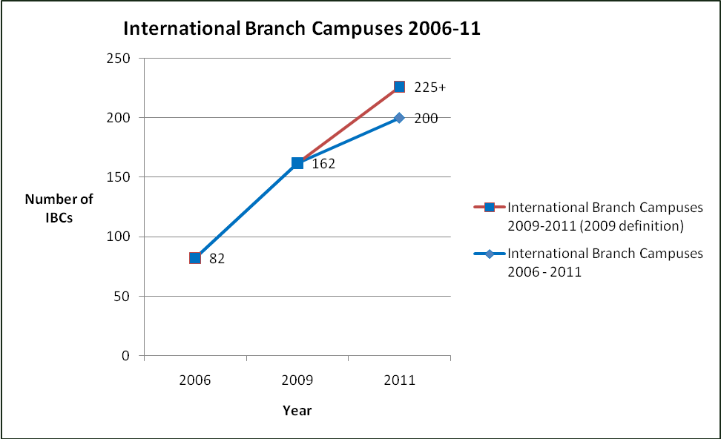

Figure 2. Global IBC provision (Home Countries), Dec 2011

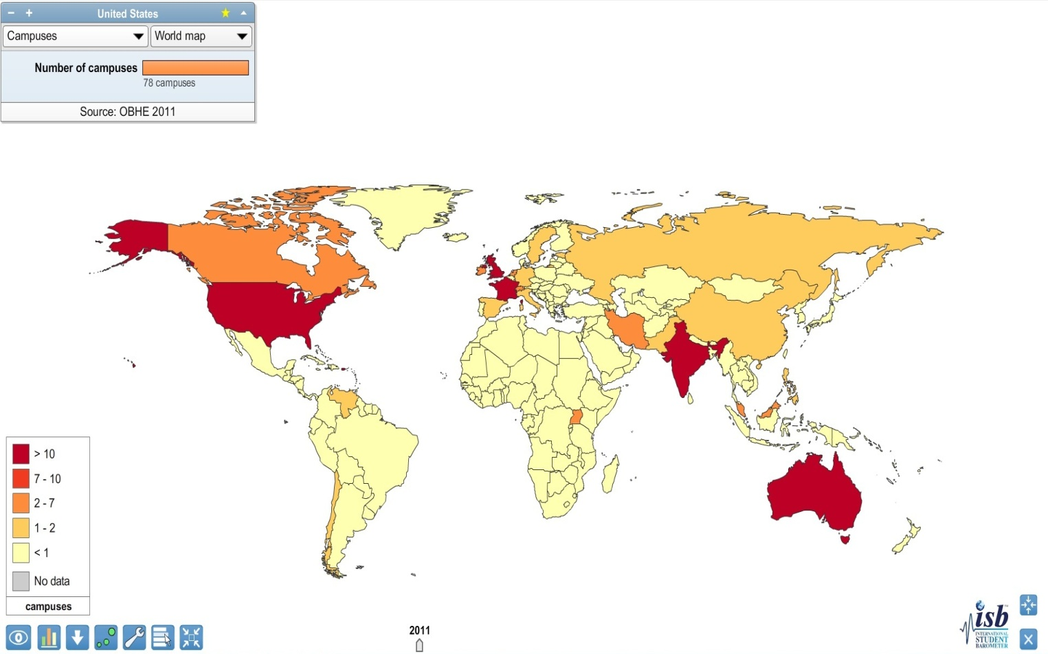

Figure 3. Global IBC provision (Host Countries), Dec 2011

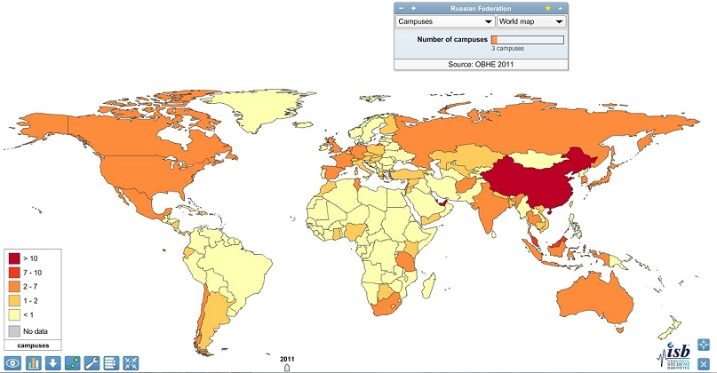

Figure 4.

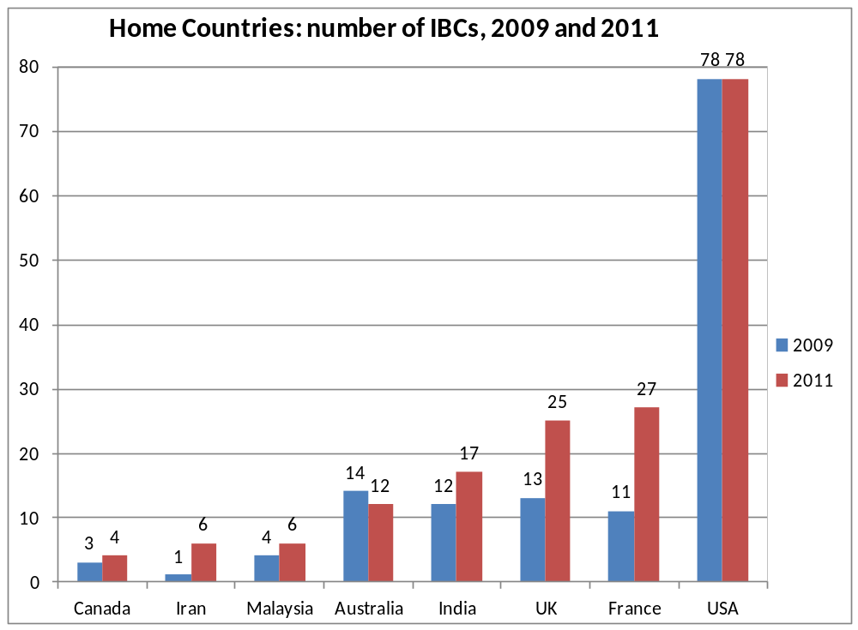

Figure 5.

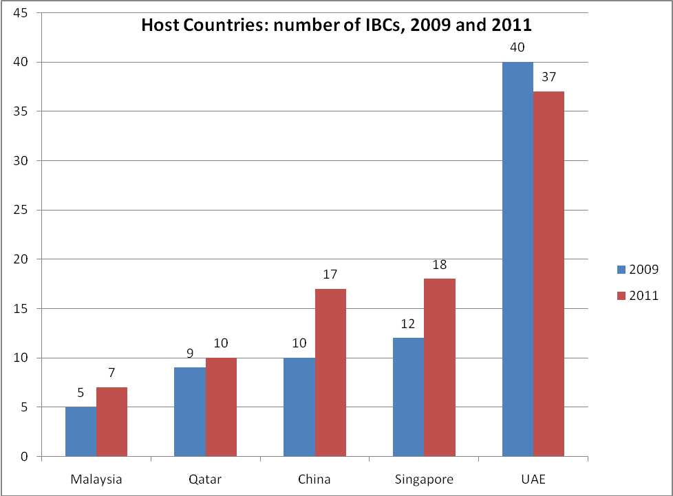
Figure 6. IBC provision in Middle East and Asia (Host Countries)

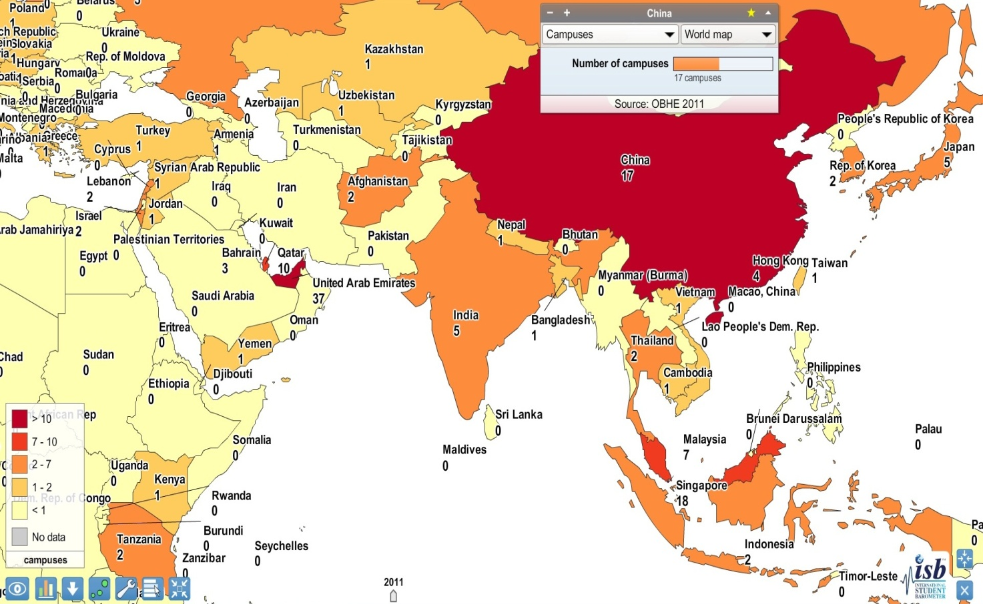

APPENDIX 3 – Choice of delivery models for offshore collaborative provision

Collaborative delivery model | Most appropriate legal structure for the model | Commercial opportunities | Commercial risks | Mitigation of risks | Risk Rating  See note *
Flying Faculty:  Home institution delivers programmes itself in the overseas country without setting up a campus. | May be required to establish a legal entity in order to operate in the country.  Consents may be required depending on the nature of collaboration and the overseas jurisdiction.  A flying faculty is normally operated in conjunction with an overseas institution. Agreements will need to be put in place. | Independent delivery and complete control.  Suitable for small discrete programmes aimed at post-graduate level.  Can be provided to a commercial body at good rates of income. | Additional administrative burden on home institution in light of independence.  Carrying on business in an overseas jurisdiction provides inherent risks with regards exposure to taxes. | Due Diligence.  Obtain overseas legal advice.  Agreeing an appropriate collaboration agreement (if applicable).  Relationship management.
On-campus provision:  Home institution creates an overseas campus in conjunction with a local partner institution. | Likely to be required to establish a legal entity in order to operate in the country.  Numerous legal agreements and permissions will be required depending on the nature of collaboration and the overseas jurisdiction. | Independent delivery and complete control.  Maximum exposure in the overseas country.  Home institution is able to hold the income received. | Carrying on business in an overseas jurisdiction provides inherent risks with regards exposure to taxes, employment regulations.  Institution may require governmental accreditation.  The home institution may need to rent or purchase premises and facilities. | Due Diligence.  Obtain overseas legal advice.  Agreeing an appropriate collaboration agreement.  Relationship management.
Joint award:  The students will study at both the home and the overseas institution (normally on a single programme) before receiving a single award from both. | Contractual agreement between the home institution and overseas institution (whether directly or through a subsidiary company of the home institution). | Attractive to prospective students.  Good control over the course content and delivery.  Home institution benefits from overseas student fees. | The home institution should ensure that it has the legal capacity (in accordance with its governing documents) to enter into dual arrangements.  High quality assurance risk in relying on the overseas institution for joint delivery. | Due Diligence.  Agreeing an appropriate collaboration agreement.  Relationship management.  Collaborate with reputable partners only and perhaps in relation to defined students (normally post-graduate)
Dual award:  The students will study at both the home institution and the overseas institution (normally on a single programme) before receiving awards from both institutions. | Contractual agreement between the home institution and overseas institution (whether directly or through a subsidiary company of the home institution). | Attractive to prospective students, as students will receive two separate awards.  Good control over the course content and delivery.  Home institution benefits from overseas student fees. | Relatively high cost. | Due Diligence.  Agreeing an appropriate collaboration agreement.  Relationship management.
Online provision:  Home institution delivers programmes itself in the overseas country by way of online modules and delivery.  Teaching would be conducted online, although some elements may be delivered on-ground at specific locations and examination and assessment may be carried out in the country. | May require local licences and/or permissions.  Direct contract with overseas students.  Possible collaboration with overseas provide or with a local IT provider. | Very wide potential market for students.  Low set-up and delivery costs.  Good control over content and delivery.  If possible, the home institution could avoid the associated risks of physically operating a business in an overseas country by ensuring the delivery vehicle, tutors and support staff to facilitate the online delivery are all based in the UK. | There could be unknown and potentially onerous regulatory requirements in the overseas country which could prevent effective delivery of the courses. | Obtain local advice in the jurisdiction of the students.  Obtain advice and expertise in online delivery.  Consider partnering with a private provider in the locality.
Franchise:  Overseas institution delivers a home institution ’s programme on its behalf. | Contractual agreement between the home institution and overseas institution (whether directly or through a subsidiary company of the home institution). | As above, but with increased control of course content and method of delivery. | Risks to the home institution’s Intellectual Property.  There is still an element of lack of control in relation to the standard and delivery of the programme by the overseas institution. | Due Diligence.  Agreeing an appropriate collaboration agreement.  Relationship management.  Intellectual Property protection.
Articulation:  Students who successfully complete a course at the overseas institution will be automatically entered onto a programme at the home institution. Similar to foundation arrangements, but at any academic level. | Contractual agreement between the home institution and overseas institution (whether directly or through a subsidiary company of the home institution). | As above. However, the potential for increased income from student fees where students progress to the home institution is increased even further. | Difficult to control the standard and delivery of the programme by the overseas institution.  However, given that the students from the overseas institution may study in the country of the home institution, there is increased potential harm to that institution’s academic standard and reputation. | Due Diligence.  Agreeing an appropriate collaboration agreement.  Relationship management.
Validation:  Home institution gives an award to students who successfully complete a course at an overseas institution. That institution and course having been determined as being sufficiently high quality to merit the award. | Contractual agreement between the home institution and overseas institution (whether directly or through a subsidiary company of the home institution). | A relatively easy way for a home institution to widen its student base and international exposure.  Potential for increased income with comparatively little capital costs or management time incurred. | Difficult to control the standard and delivery of the programme by the overseas institution.  Well reported incidences of validation arrangements affecting the reputation and academic standing of the home institution . | Due Diligence  Agreeing an appropriate collaboration agreement.  Relationship management.

*CAUTIONARY NOTE: Risk Rating – the “RAG” column on the extreme right is included by way of illustration only; different categories of risk, e.g. financial, reputational, academic control/input, local regulatory etc, call for a careful analysis; separate columns for likelihood of occurrence and impact could be added; work-in-progress.

APPENDIX 4 – UK Quality Code for Higher Education: Key Indicators.

The Quality Code is the definitive reference point for all those involved in delivering higher education which leads to an award from or is validated by a UK higher education provider.

It is published by the Quality Assurance Agency for Higher Education and includes a Chapter on the Management of Collaborative Arrangements. The Chapter sets out a series of Indicators which UK HE providers have agreed represent sound practice and which they are required by the Quality Assurance Agency to meet.

The Indicators

Indicator 1
The awarding institution is responsible for the academic standards of all awards
granted in its name.
Indicator 2
The academic standards of all awards made under a collaborative arrangement should
meet the Expectations of the Quality Code.
Indicator 3
Collaborative arrangements should be negotiated, agreed and managed in accordance
with the formally stated policies and procedures of the awarding institution.
Indicator 4
An up-to-date and authoritative record of the awarding institution's collaborative
partnerships and agents, and a listing of its collaborative programmes operated
through those partnerships or agencies, should form part of the institution's publicly
available information.
Indicator 5
The awarding institution should inform any professional, statutory and regulatory
body (PSRB), which has approved or recognised a programme that is the subject
of a possible or actual collaborative arrangement, of its proposals and of any final
agreements which involve the programme. The status of the programme in respect of
PSRB recognition should be made clear to prospective students.
Indicator 6
The awarding institution's policies and procedures should ensure that there are
adequate safeguards against financial or other temptations that might compromise
academic standards or the quality of learning opportunities.
Indicator 7
Collaborative arrangements should be fully costed and should be accounted for
accurately and fully.
32

Indicator 8
The educational objectives of a partner organisation should be compatible with those
of the awarding institution.
Indicator 9
An awarding institution should undertake, with due diligence, an investigation to
satisfy itself about the good standing of a prospective partner or agent, and of their
capacity to fulfil their designated role in the arrangement. This investigation should
include the legal status of the prospective partner or agent, and its capacity in law to
contract with the awarding institution.
Indicator 10

There should be a written and legally binding agreement or contract setting out the
rights and obligations of the parties and signed by the authorised representatives of
the awarding institution and the partner organisation or agent.
Indicator 11
The agreement or contract should make clear that any serial arrangement whereby
the partner organisation offers approved collaborative provision elsewhere or assigns,
through an arrangement of its own, powers delegated to it by the awarding institution,
may be undertaken only with the express written permission of the awarding
institution in each instance. The awarding institution is responsible for ensuring that it
retains proper control of the academic standards of awards offered through any such
arrangements.
Indicator 12

The awarding institution is ultimately responsible for ensuring that the quality of
learning opportunities offered through a collaborative arrangement is adequate to
enable a student to achieve the academic standard required for its award.
Indicator 13
An awarding institution that engages with another authorised awarding body jointly
to provide a programme of study leading to a dual or joint academic award should
be able to satisfy itself that it has the legal capacity to do so, and that the academic
standard of the award, referenced to the FHEQ (the SCQF in Scotland), meets its own
expectations, irrespective of the expectations of the partner awarding body.
Indicator 14
The scope, coverage and assessment strategy of a collaborative programme should
be described in a programme specification that refers to relevant subject benchmark
statements and the level of award, and that is readily available and comprehensible to
stakeholders.
Indicator 15

The awarding institution should make appropriate use of the Quality Code to ensure
that all aspects of the Quality Code relevant to the collaborative arrangement are
The UK Quality Code for Higher Education
33
addressed by itself and/or the partner organisation, and should make clear respective
responsibilities of the awarding institution and a partner organisation in terms of
addressing the Indicators of the Quality Code.

Indicator 16
In the case of a collaborative arrangement with a partner organisation, or engagement
with an agent, the awarding institution should be able to satisfy itself that the terms
and conditions that were originally approved have been, and continue to be, met.
Indicator 17

The awarding institution should be able to satisfy itself that staff engaged in delivering
or supporting a collaborative programme are appropriately qualified for their role,
and that a partner organisation has effective measures to monitor and assure the
proficiency of such staff.

Indicator 18

The awarding institution should ensure that arrangements for admission to the
collaborative programme take into account the Expectations and Indicators of Chapter
B2: Admissions of the Quality Code.

Indicator 19

The awarding institution is responsible for ensuring that the outcomes of assessment
for a programme provided under a collaborative arrangement meet the specified
academic level of the award as defined in the FHEQ (or SCQF in Scotland), in the
context of the relevant subject benchmark statement(s).

Indicator 20

The awarding institution should ensure that a partner organisation involved in the
assessment of students understands and follows the requirements approved by the
awarding institution for the conduct of assessments, which themselves should be
referenced to Chapter A6: Assessment of achievement of learning outcomes, and Chapter B6: Assessment of students and accreditation of prior learning of the Quality Code.

Indicator 21
External examining procedures for programmes offered through collaborative
arrangements should be consistent with the awarding institution's normal practices.

Indicator 22
The awarding institution must retain ultimate responsibility for the appointment and
functions of external examiners. The recruitment and selection of external examiners
should be referenced to Chapter B7: External examining of the Quality Code.

Indicator 23
External examiners of collaborative programmes must receive briefing and guidance
approved by the awarding institution sufficient for them to fulfil their role effectively.

Indicator 24

An awarding institution should ensure that:

- It has sole authority for awarding certificates and transcripts relating to the
programmes of study delivered through collaborative arrangements

- The certificate and/or transcript records (a) the principal language of instruction
where this was not English, and (b) the language of assessment if that was not
English (except for awards for programmes or their elements relating to the
study of a foreign language where the principal language of assessment is also
the language of study). Where this information is recorded on the transcript
only, the certificate should refer to the existence of the transcript. References
here to ‘a foreign language’ and ‘a language that is not English’ do not include
programmes provided and assessed by Welsh institutions in the Welsh language

- subject to any overriding statutory or other legal provision in any relevant
jurisdiction, the certificate and/or the transcript should record the name and
location of any partner organisation engaged in delivery of the programme of
study.

Indicator 25

The minimum level of information that prospective and registered students should
have about a collaborative programme is the programme specification approved by
the awarding institution.

Indicator 26

The information made available to prospective students and those registered on a
collaborative programme should include information to students about the appropriate
channels for particular concerns, complaints and appeals, making clear the channels
through which they can contact the awarding institution directly.

Indicator 27

The awarding institution should monitor regularly the information given by the partner
organisation or agent to prospective students and those registered on a collaborative
programme.

Indicator 28

The awarding institution should ensure that it has effective control over the accuracy
of all public information, publicity and promotional activity relating to its collaborative
provision.

